**Real Time Project :2 -** ✔ Practical 28 E-Commerce Microservice (**JAVA + PYTHON + GO + .net**) Web application Deployment on Kubernetes Cluster



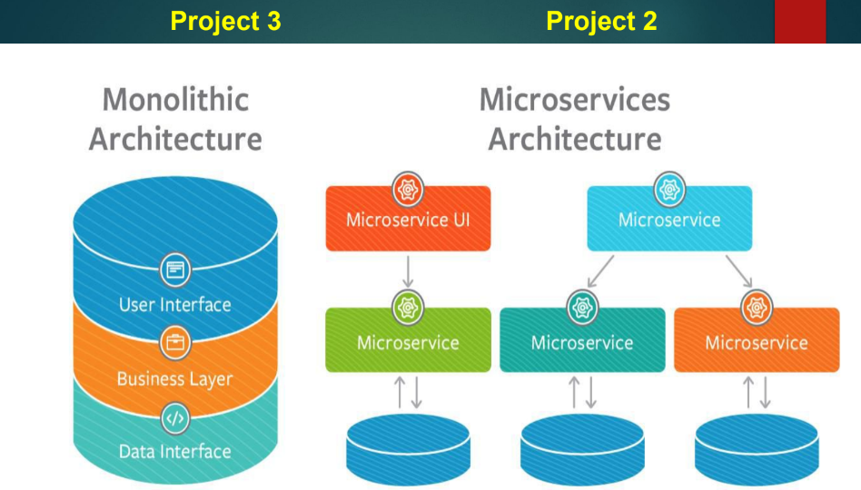

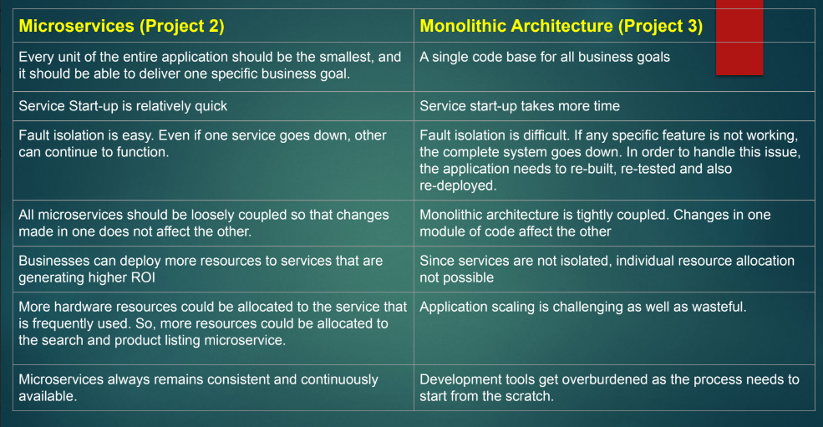

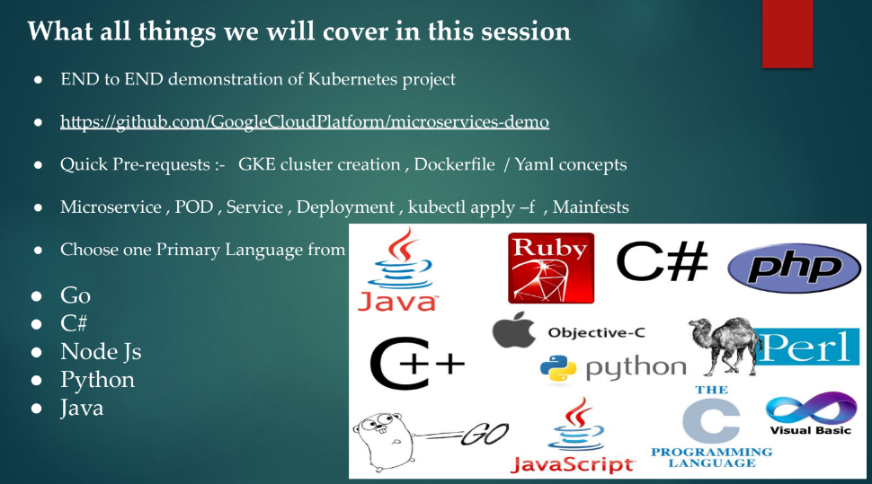

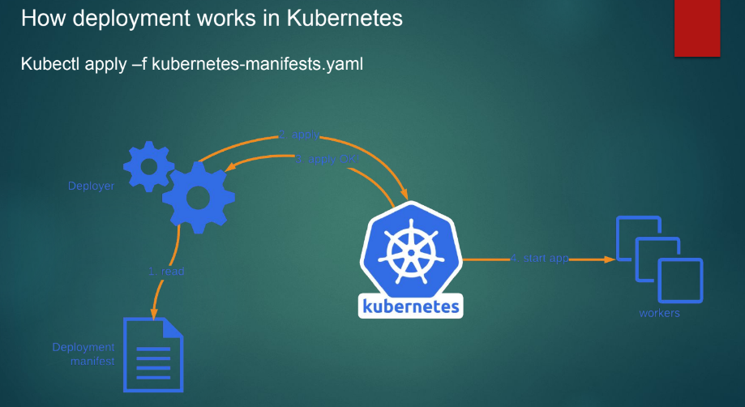

Just like example E-commerce platform Flipkart.com

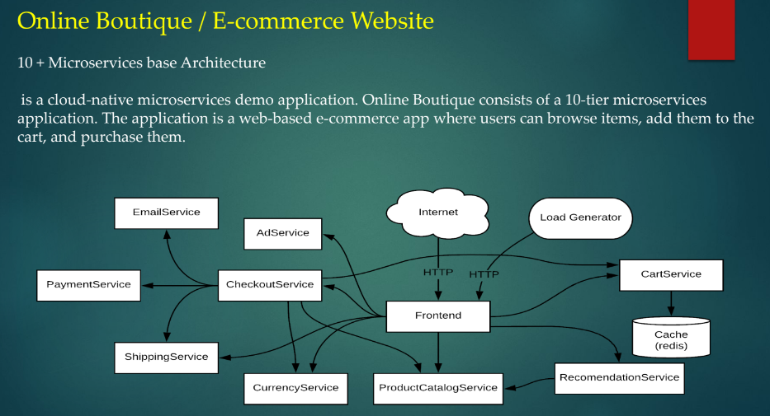

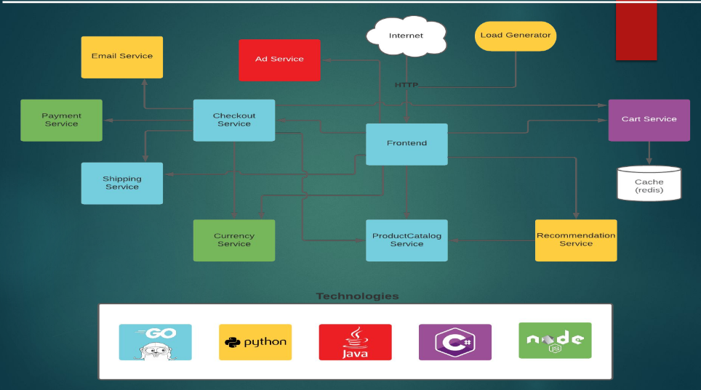

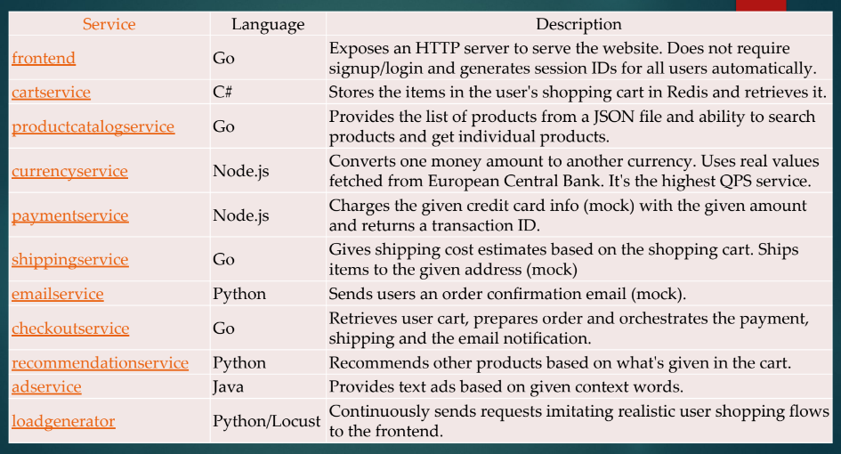

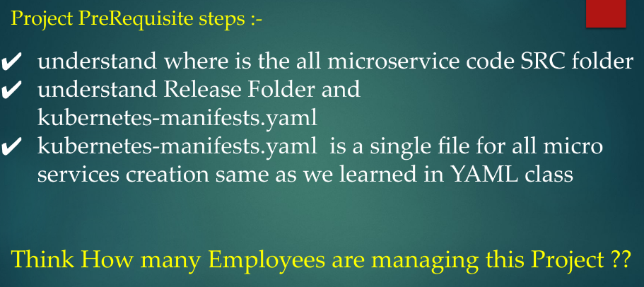

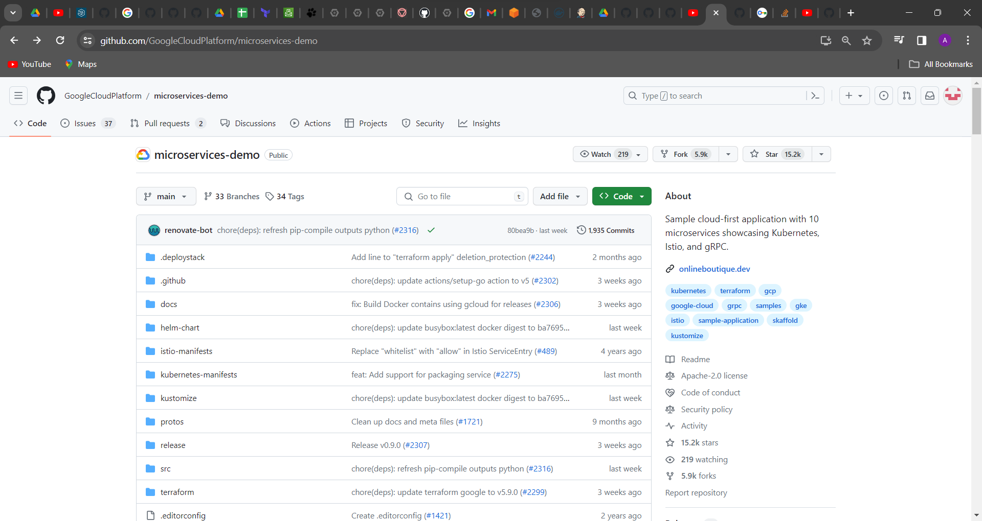

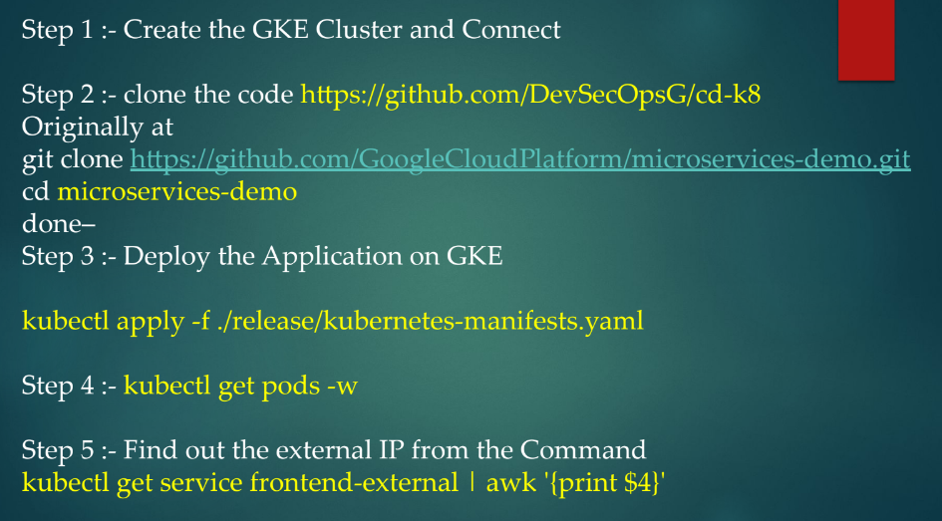

<https://github.com/GoogleCloudPlatform/microservices-demo>

then go to GCP account 🡪 Kubernative engine 🡪 cluster

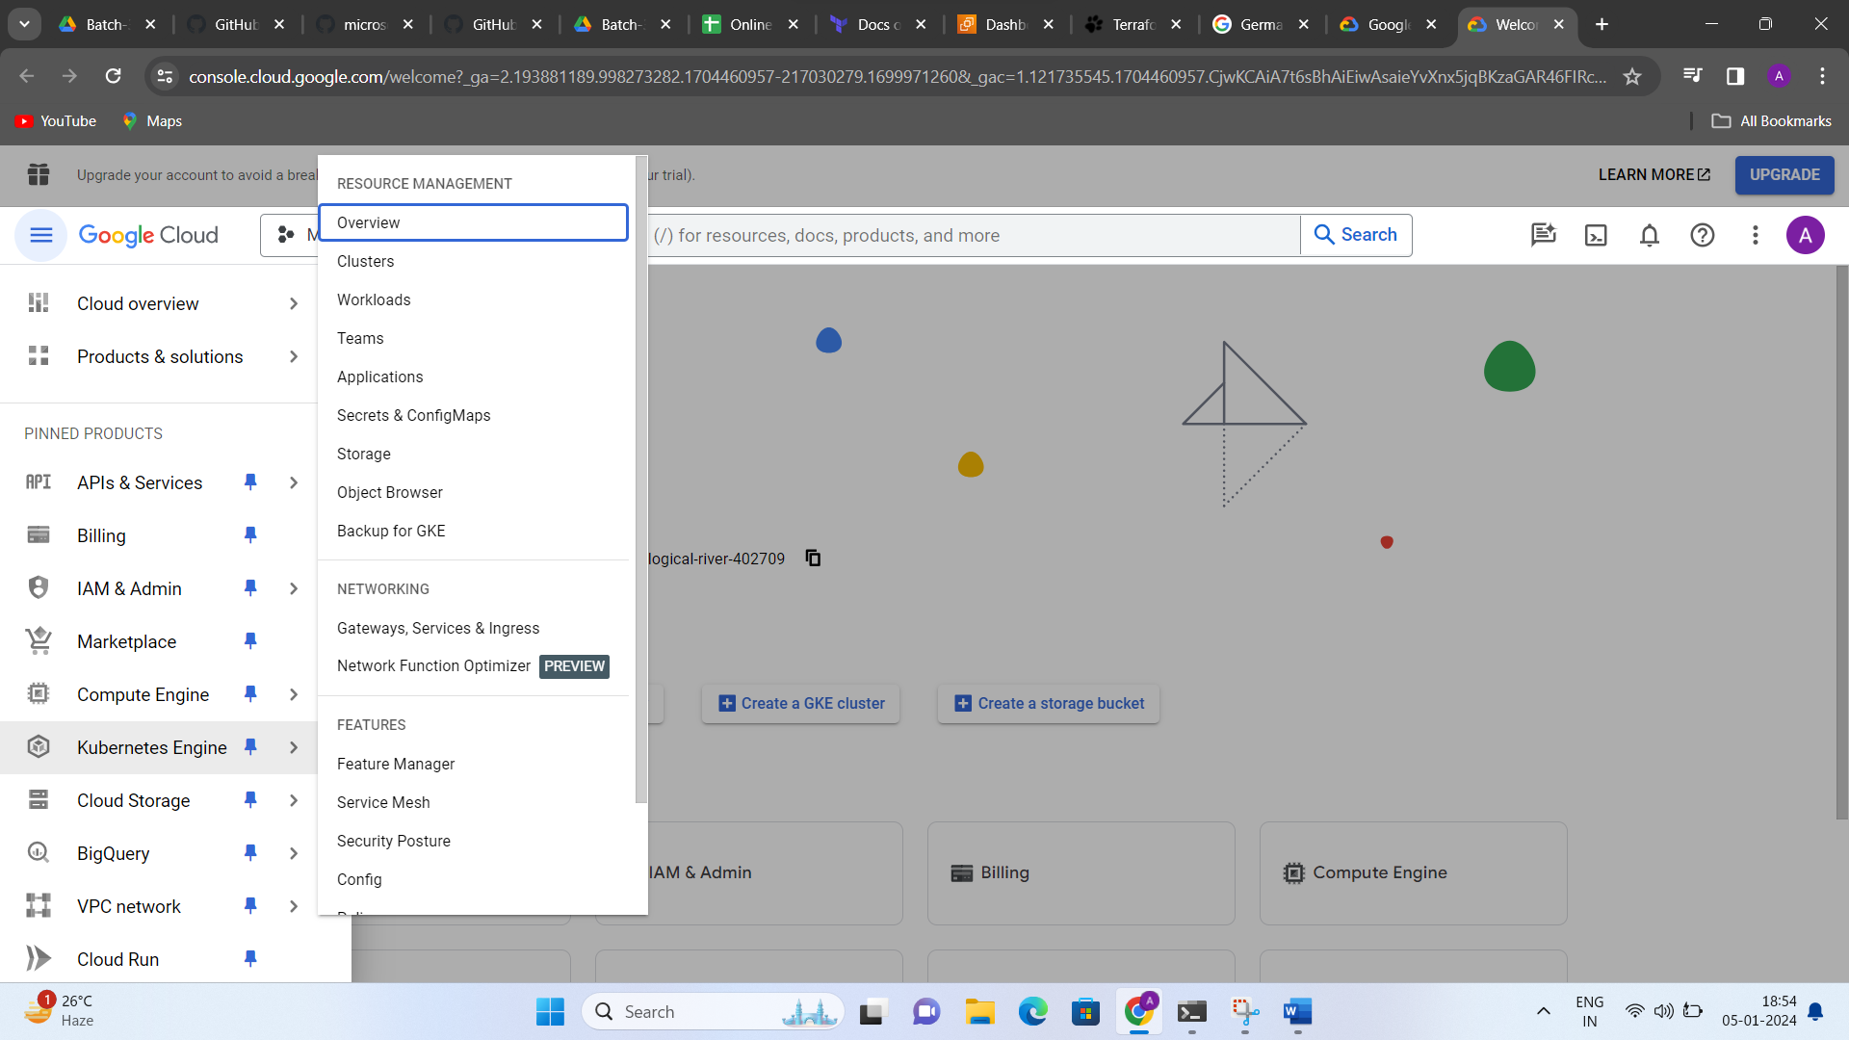

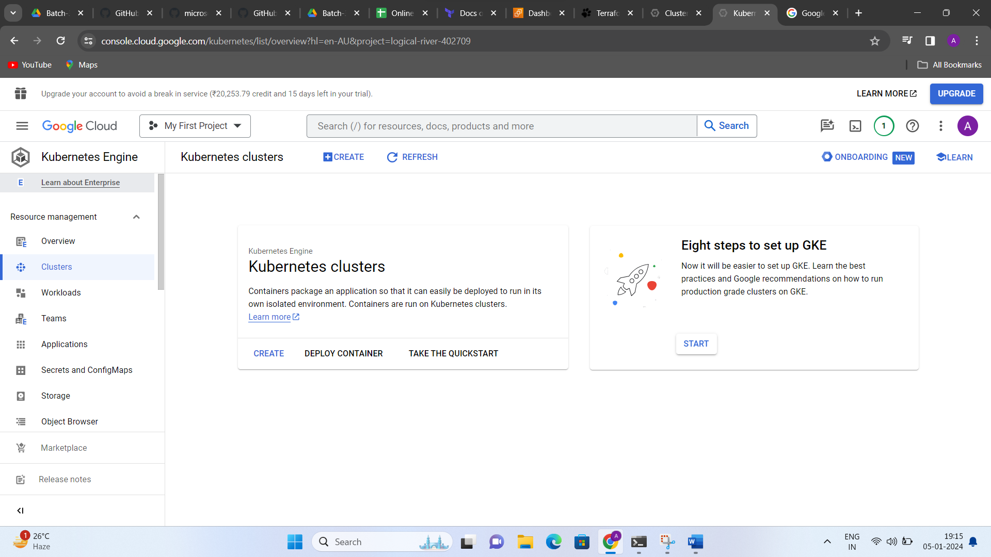

Click on Create option

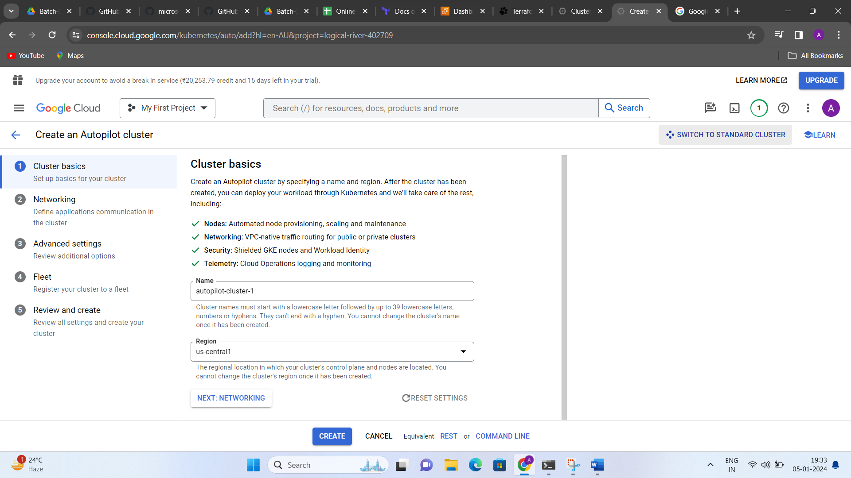

Then click on “Switch To Standard Cluster”

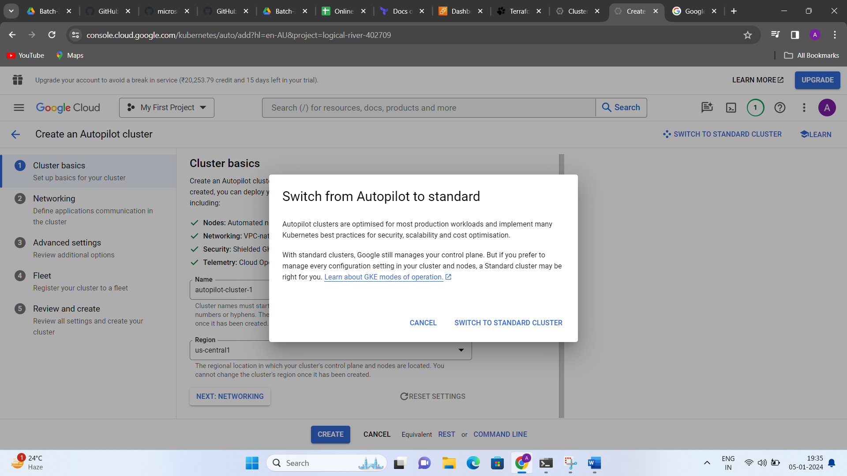

In Nodes you can change boot disk size as you wants

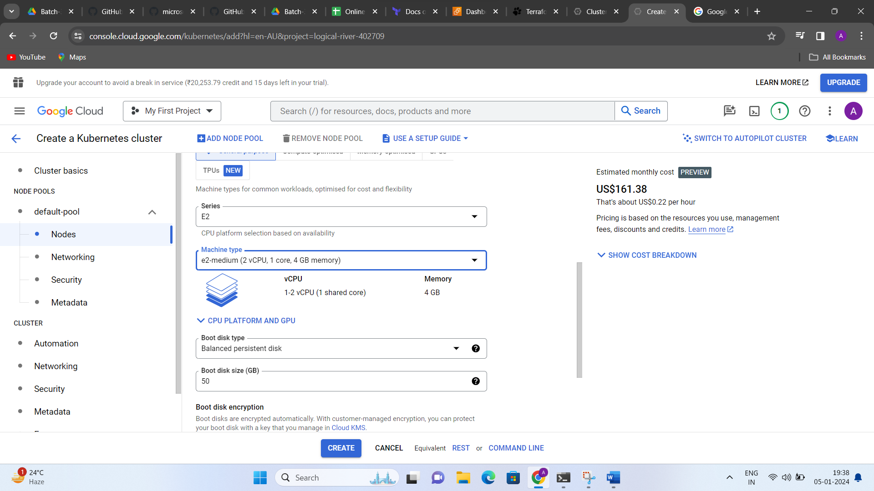

Go to click on command line

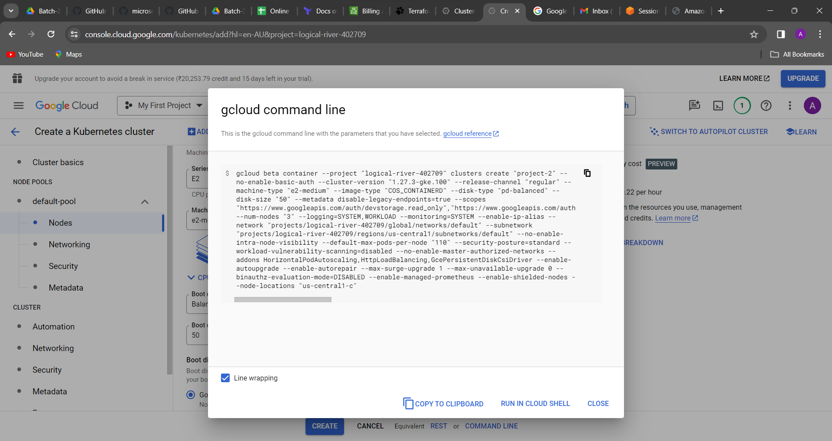

Either you can copy this command and put it in your notepad

gcloud beta container --project "logical-river-402709" clusters create "project-2" --no-enable-basic-auth --cluster-version "1.27.3-gke.100" --release-channel "regular" --machine-type "e2-medium" --image-type "COS_CONTAINERD" --disk-type "pd-balanced" --disk-size "50" --metadata disable-legacy-endpoints=true --scopes "https://www.googleapis.com/auth/devstorage.read_only","https://www.googleapis.com/auth/logging.write","https://www.googleapis.com/auth/monitoring","https://www.googleapis.com/auth/servicecontrol","https://www.googleapis.com/auth/service.management.readonly","https://www.googleapis.com/auth/trace.append" --num-nodes "3" --logging=SYSTEM,WORKLOAD --monitoring=SYSTEM --enable-ip-alias --network "projects/logical-river-402709/global/networks/default" --subnetwork "projects/logical-river-402709/regions/us-central1/subnetworks/default" --no-enable-intra-node-visibility --default-max-pods-per-node "110" --security-posture=standard --workload-vulnerability-scanning=disabled --no-enable-master-authorized-networks --addons HorizontalPodAutoscaling,HttpLoadBalancing,GcePersistentDiskCsiDriver --enable-autoupgrade --enable-autorepair --max-surge-upgrade 1 --max-unavailable-upgrade 0 --binauthz-evaluation-mode=DISABLED --enable-managed-prometheus --enable-shielded-nodes --node-locations "us-central1-c"

gff

Then you have click on “Run in cloud shell”

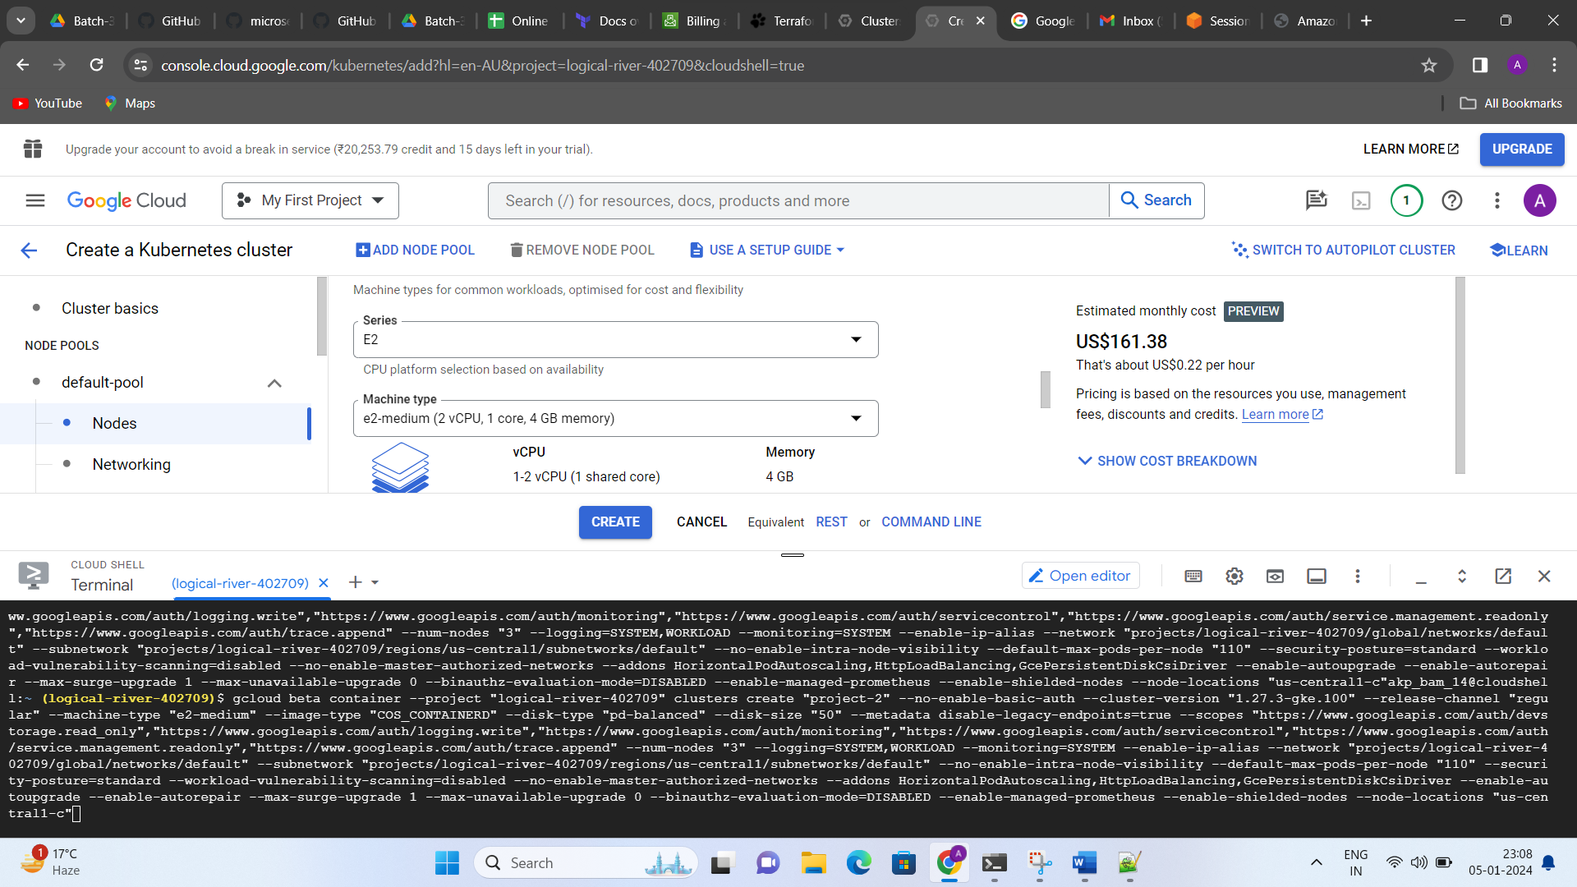

It was automatic command lines are paste in cloud shell

Then press enter

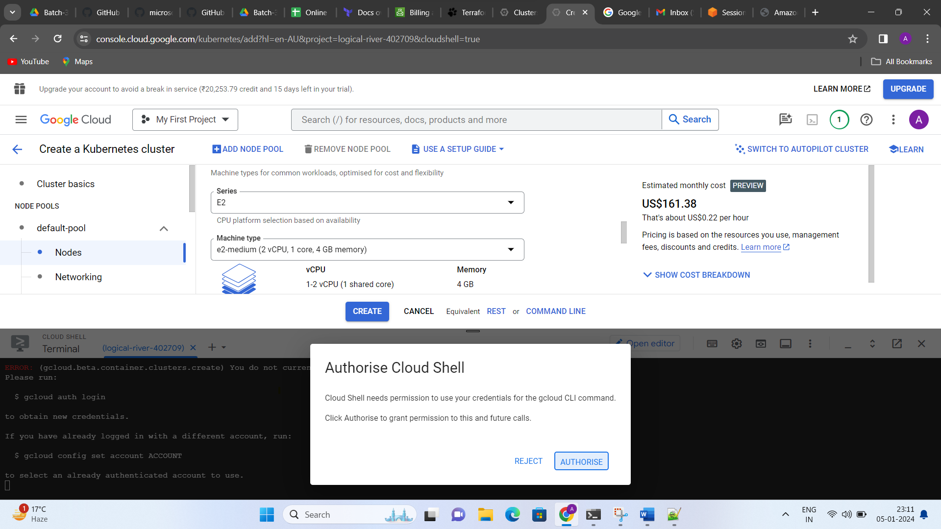

Click on Authorize and enter option

Then it will be showing an error while you can click on by default create option

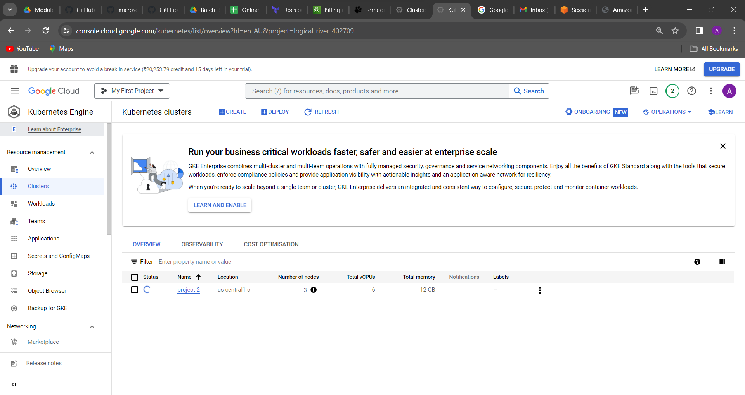

Copy this cloud shell : kubectl run jenkins --image=jenkins/jenkins:lts

Then go to connect option -> Run in cloud shell

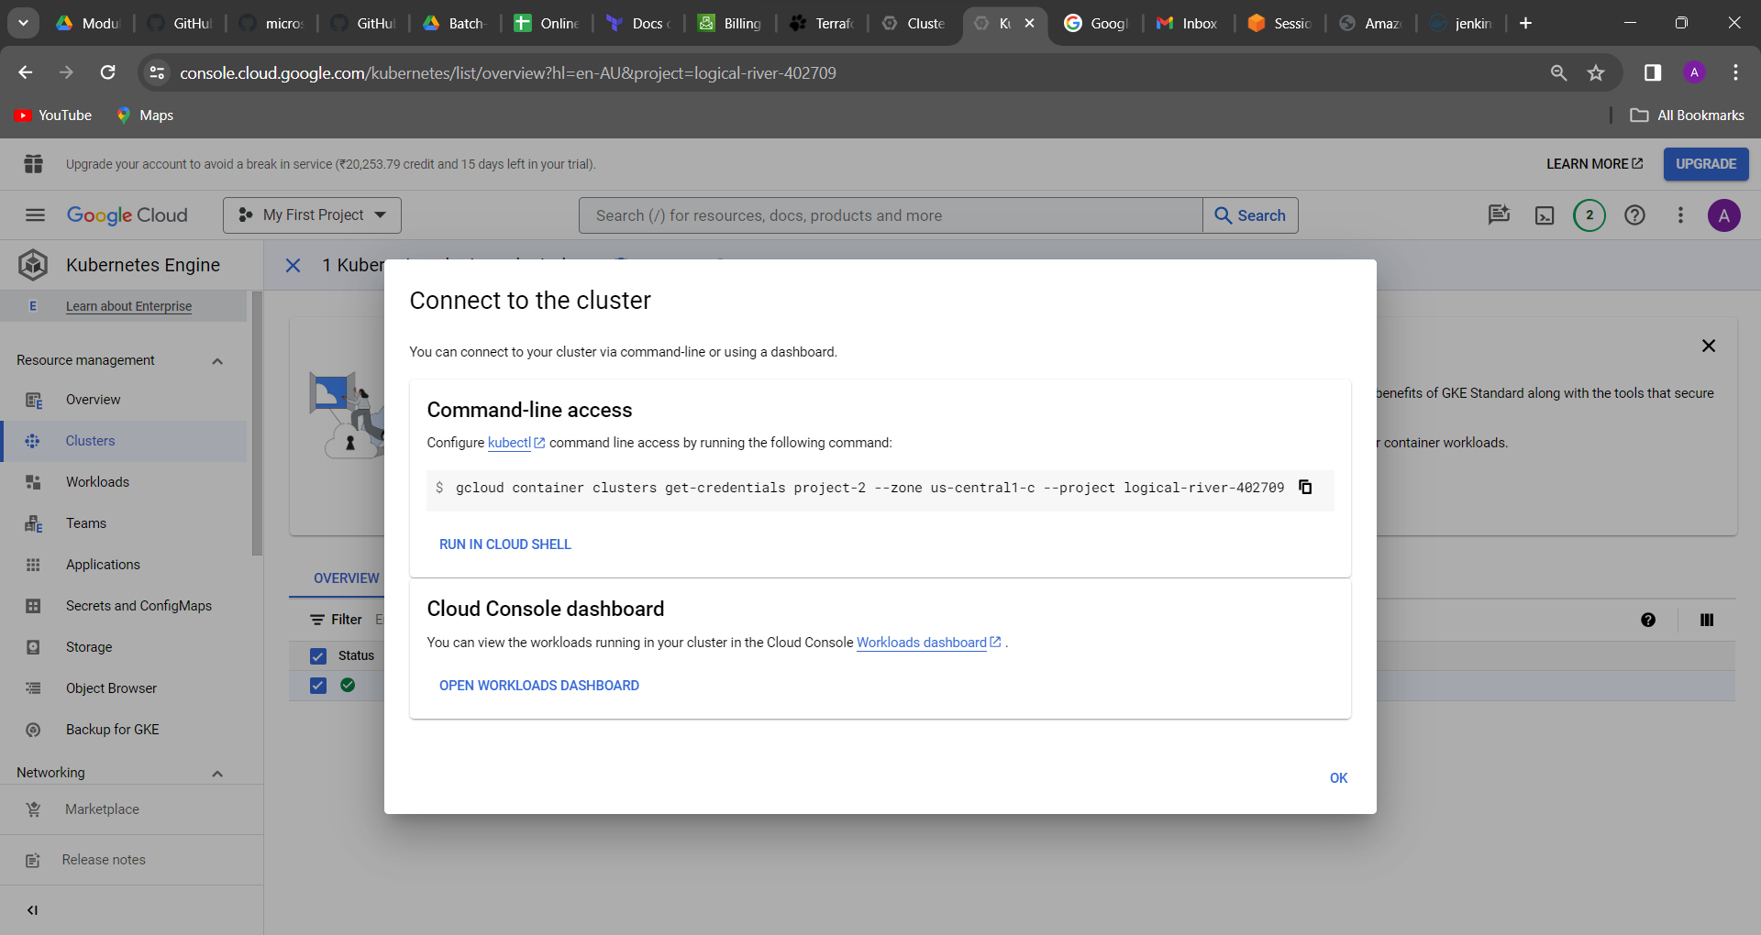

Then press enter option

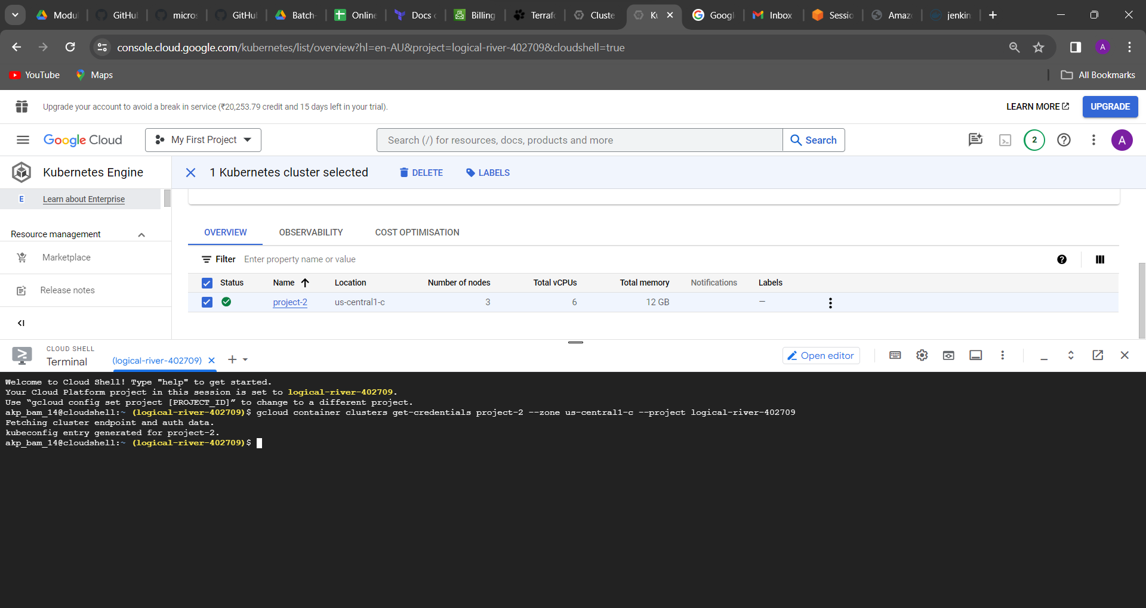

Then coming to the option in workloads and select it cluster

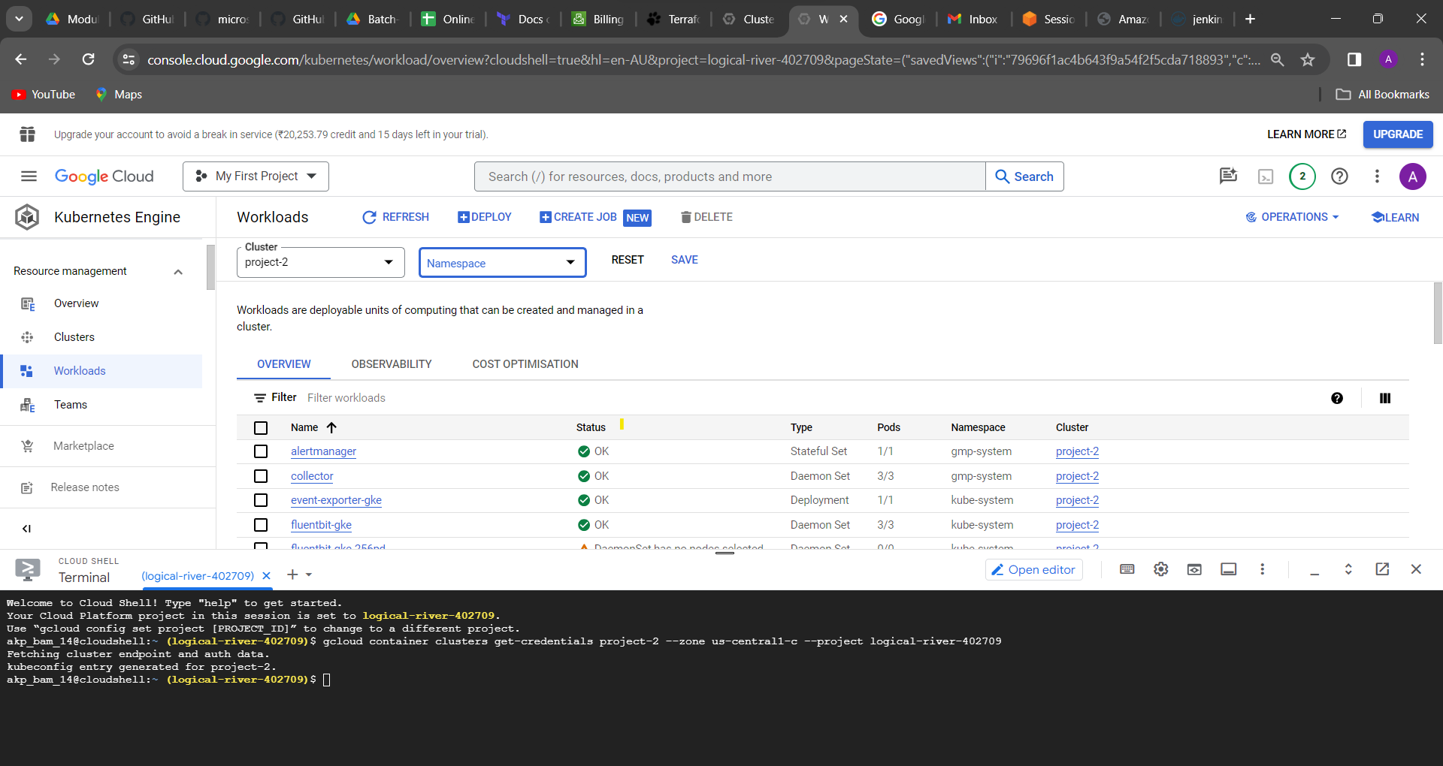

In cloud shell type command: “kubectl get pods - -all-namespaces”

It gives all pods in kubernates showing

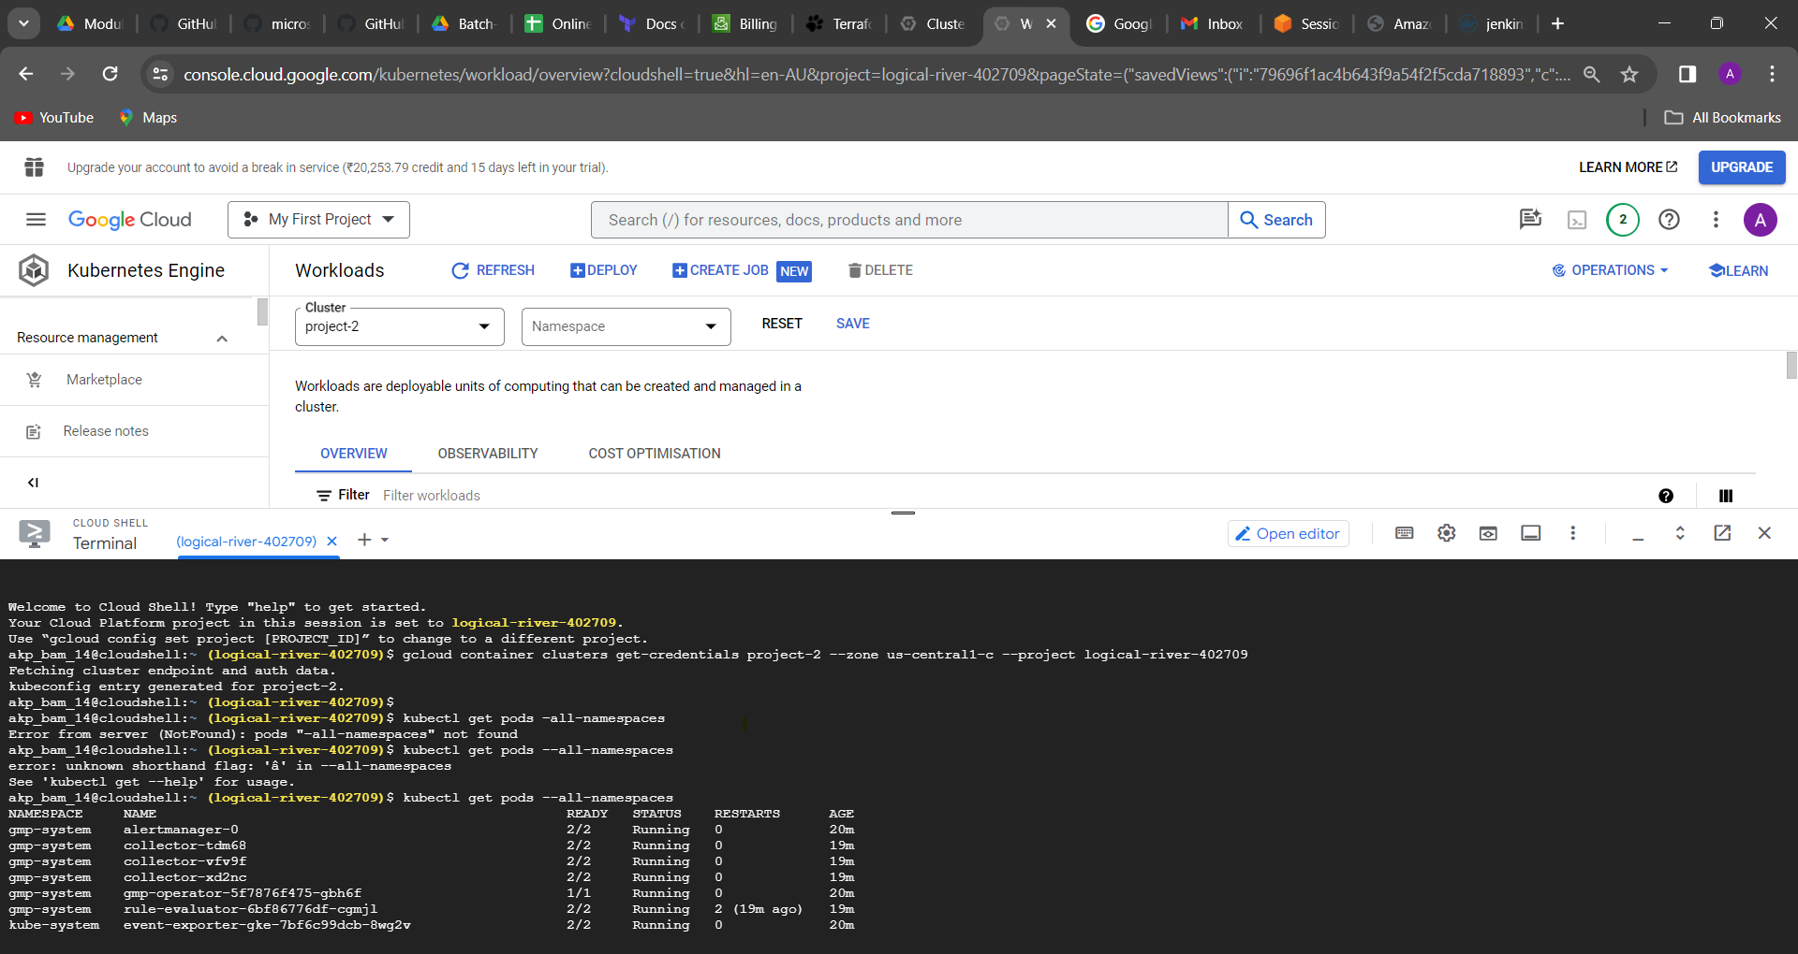

Type command

Kubectl get pods

kubectl run jenkins - -image=jenkins/Jenkins:lts

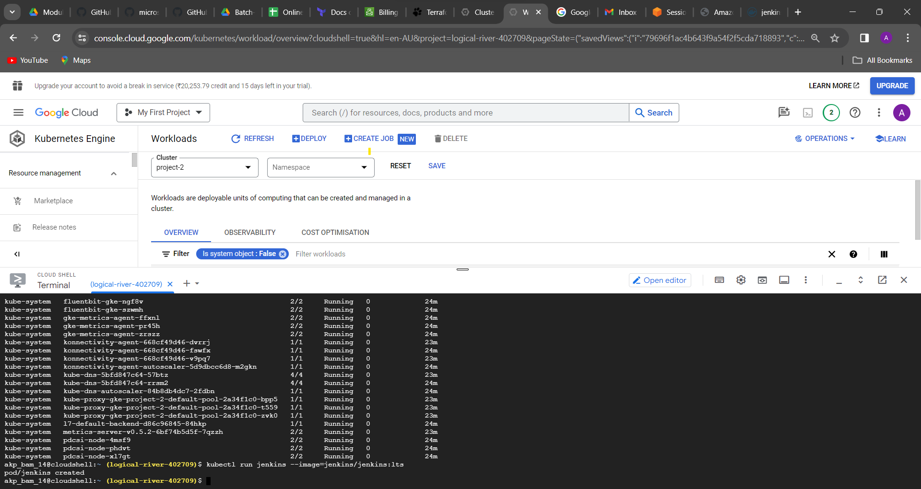

Then go to refresh button and check it here Jenkins is upon running showing

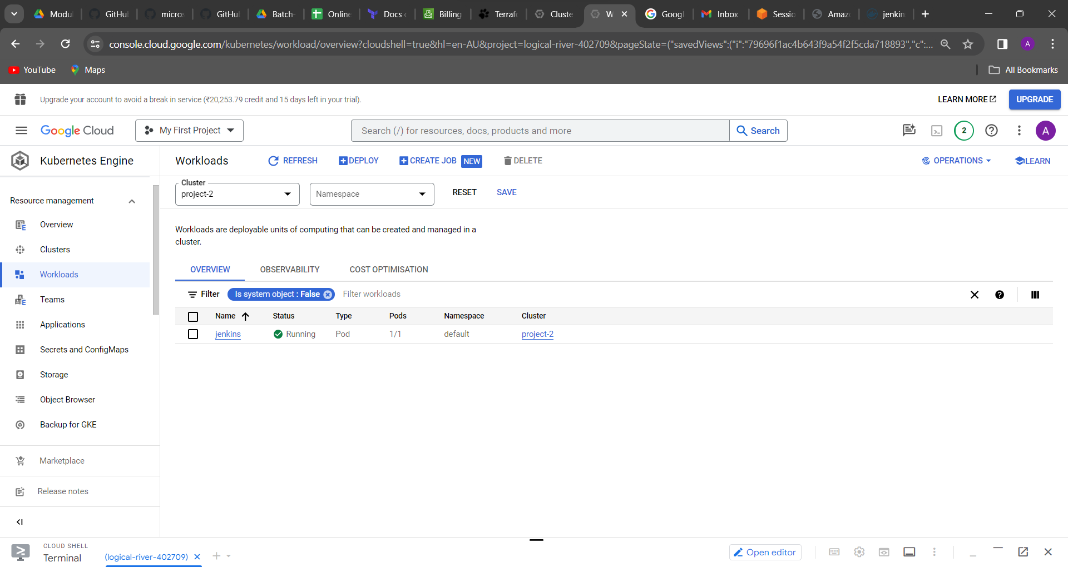

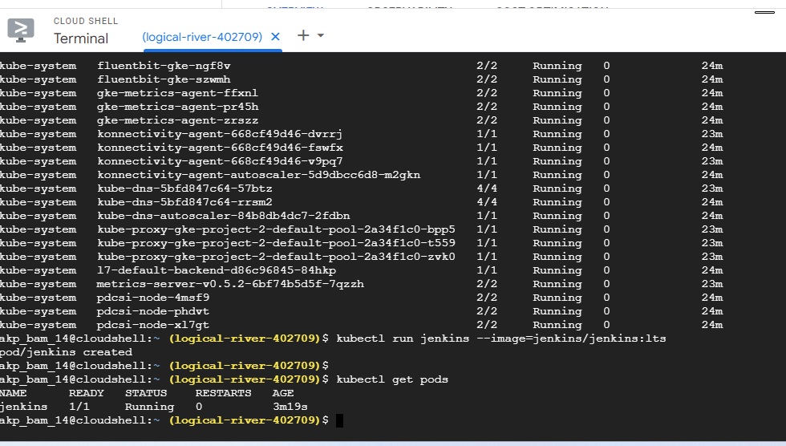

Click on jenkin and go to expose

Type in port 8080

Click on expose

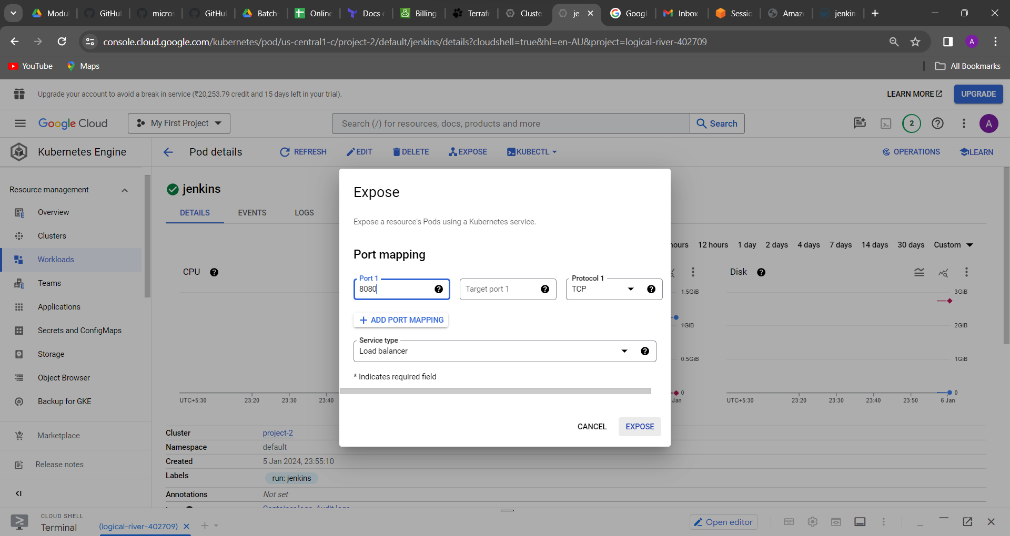

Then go to in networking🡪 service&Ingress

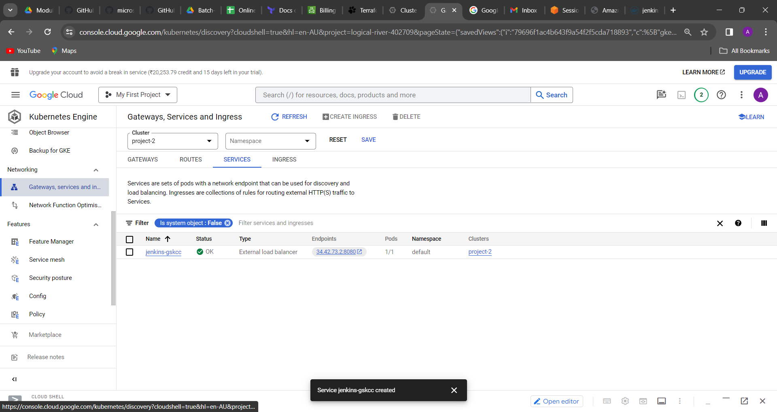

Type command: kubectl get svc

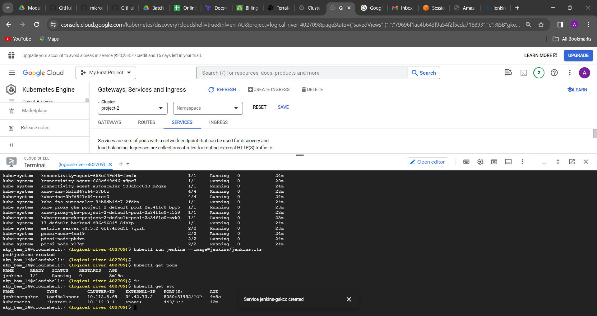

Copy this external ip with port8080 browse it: 34.42.73.2:8080

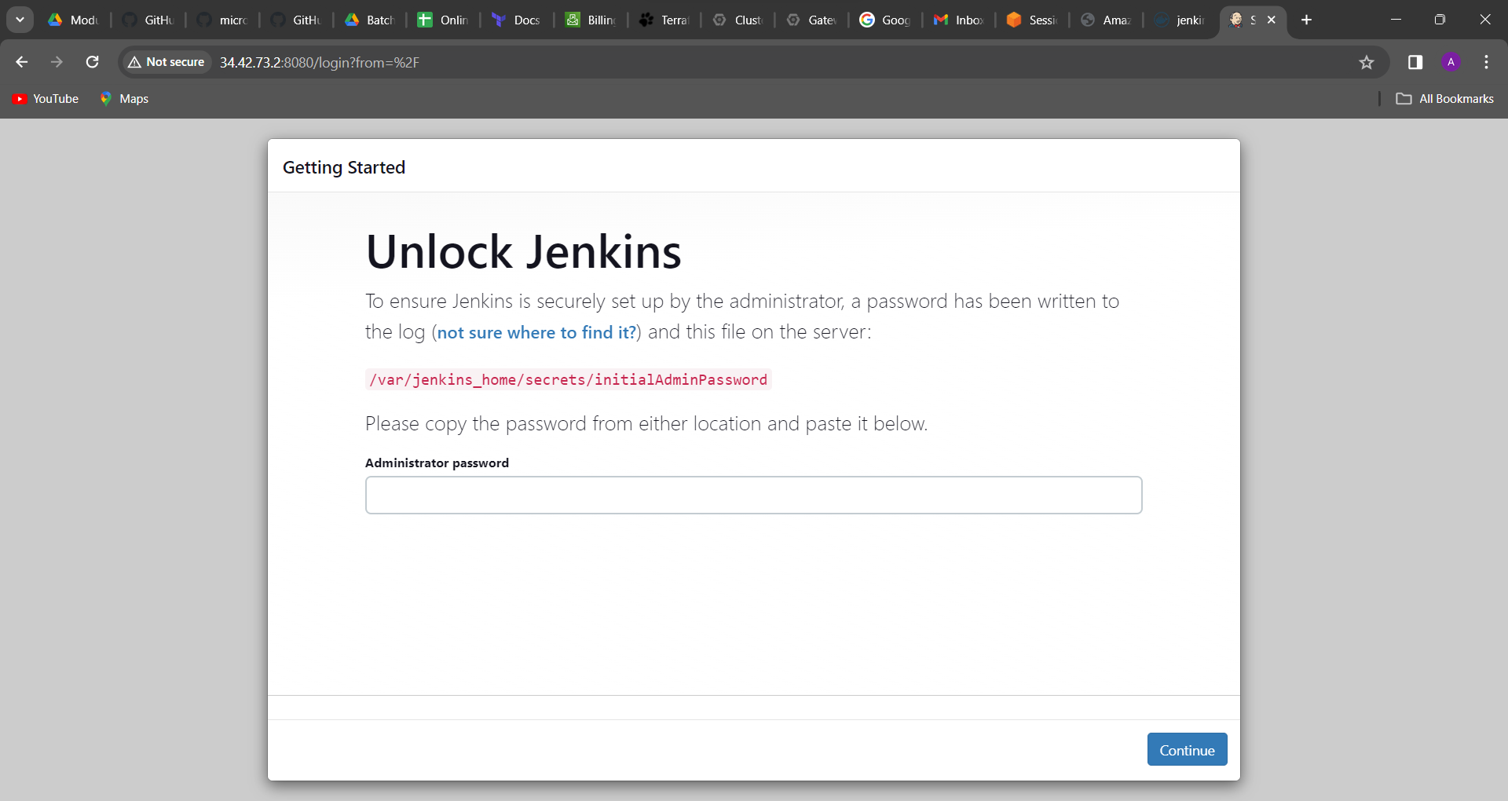

How can I find the passwd

Copy this path and paste in command line

First you have to type command inside go to the Jenkins

kubectl exec -it jenkins bin/bash

cat /var/jenkins_home/secrets/initialAdminPassword

passward: 5dce6e88a83a41e8b3c69e9fe0c2c4f2

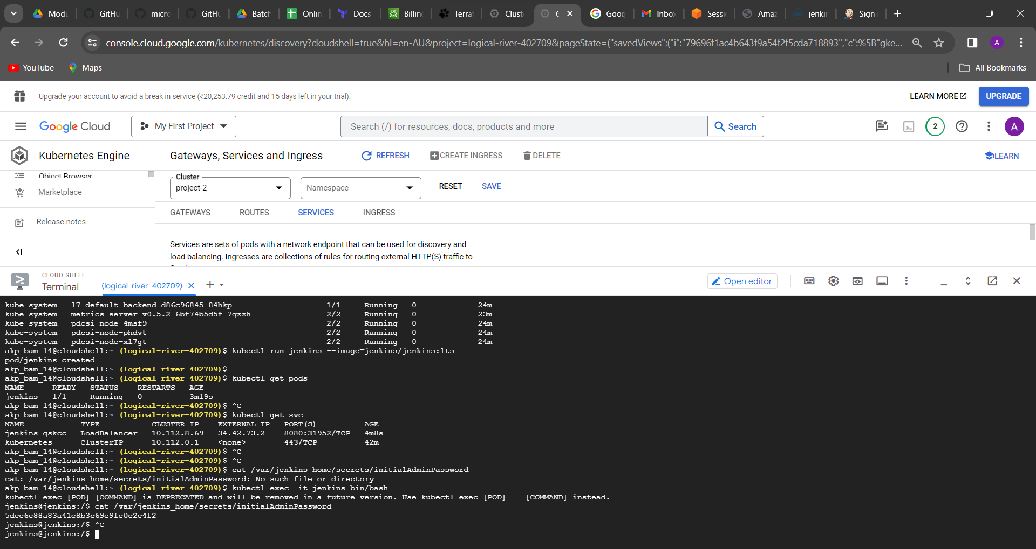

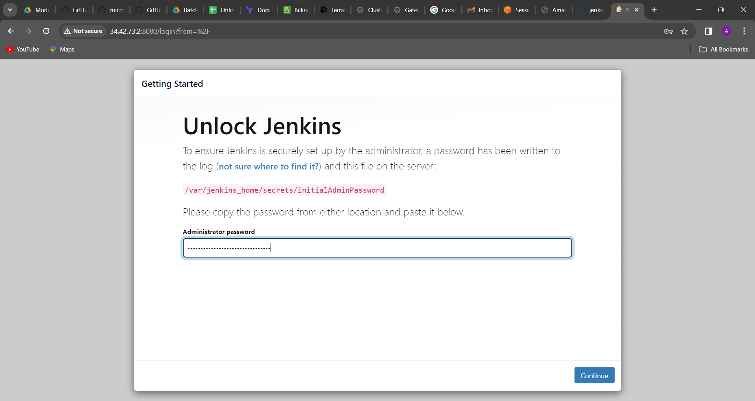

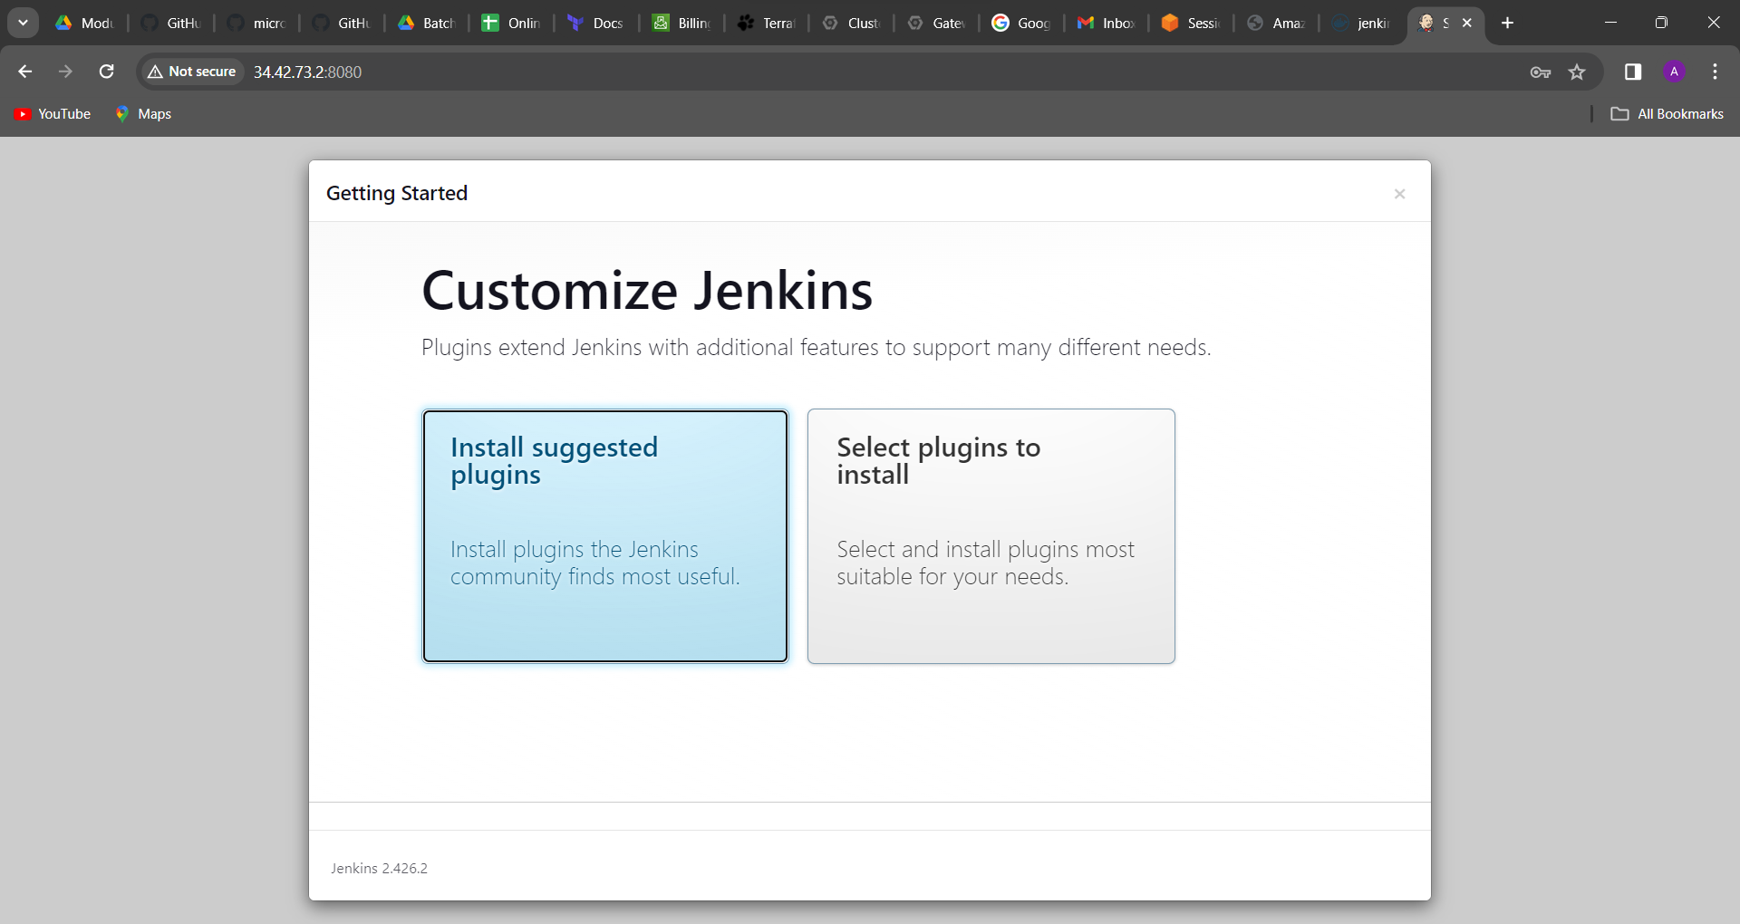

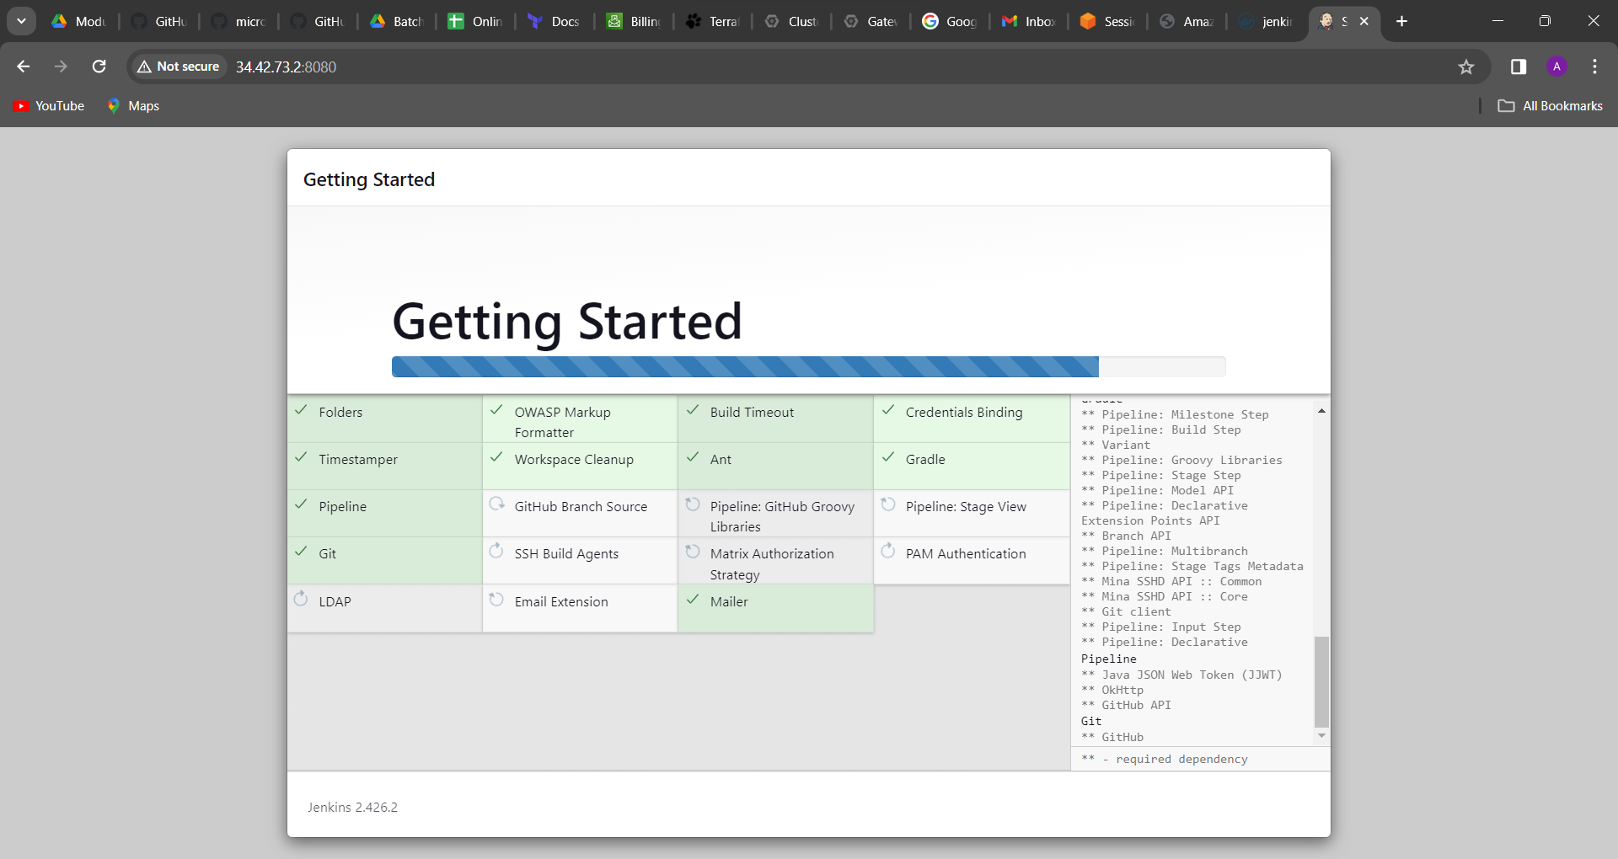

Then type “exit” command

kubectl get pods

kubectl get pods -o wide

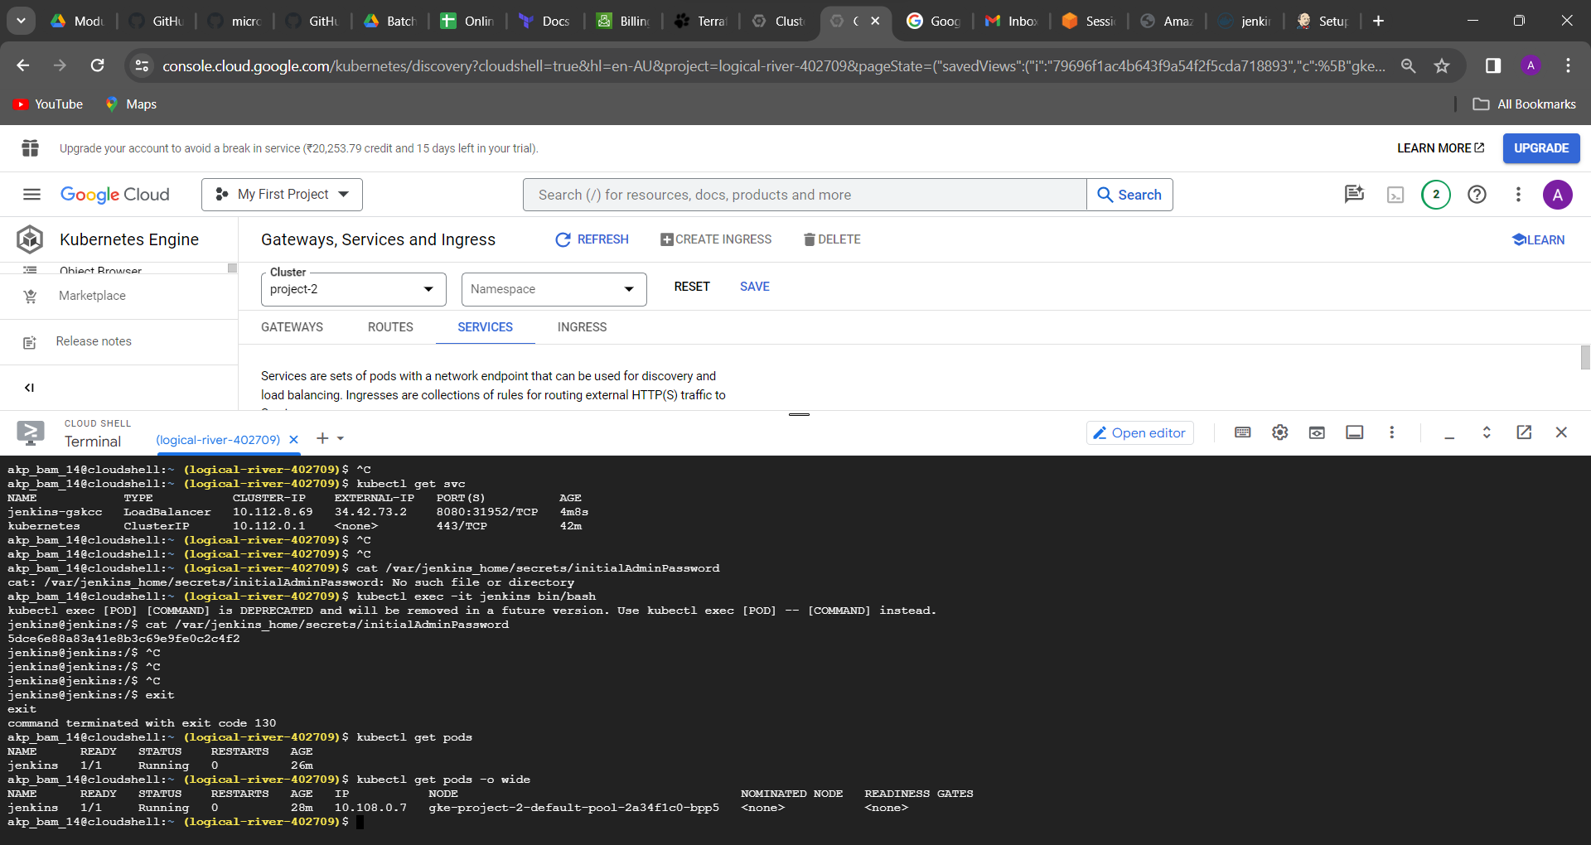



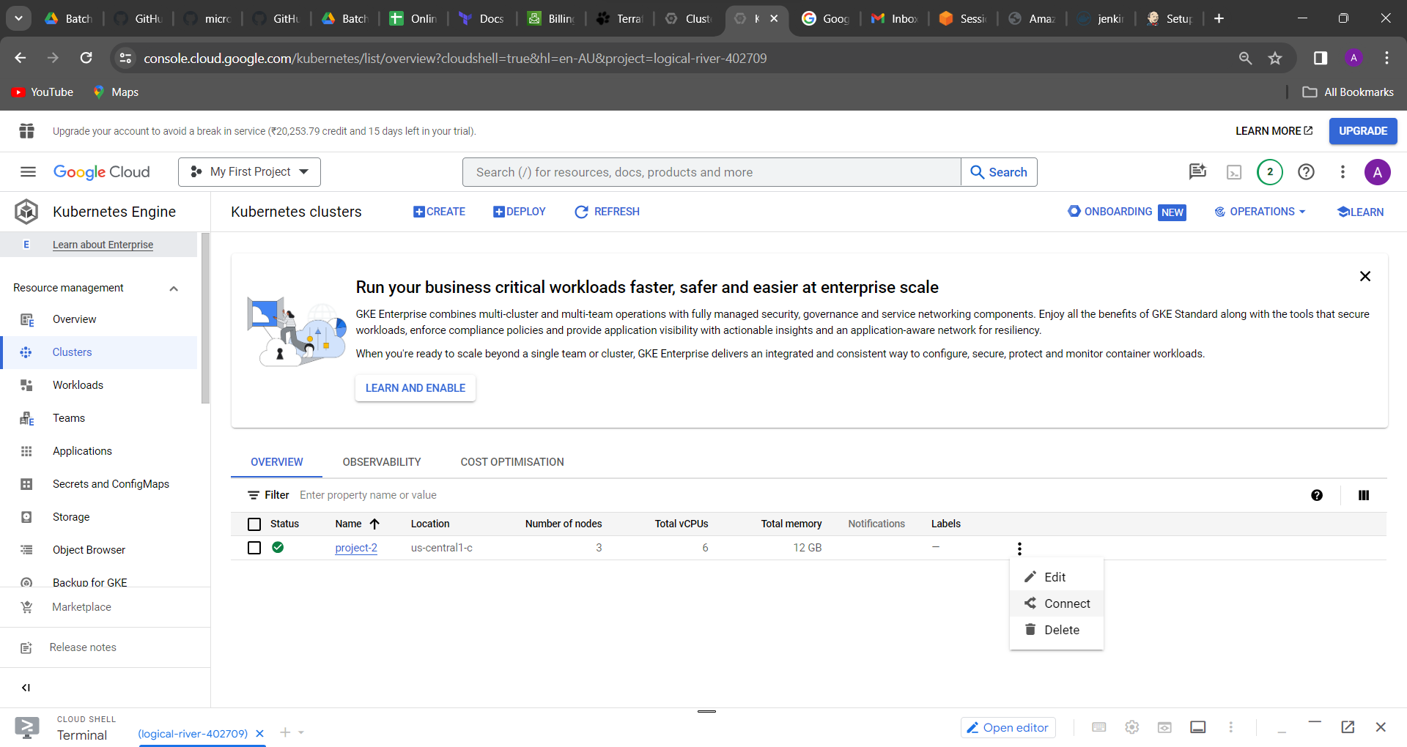click on connect

And run in cloud shell

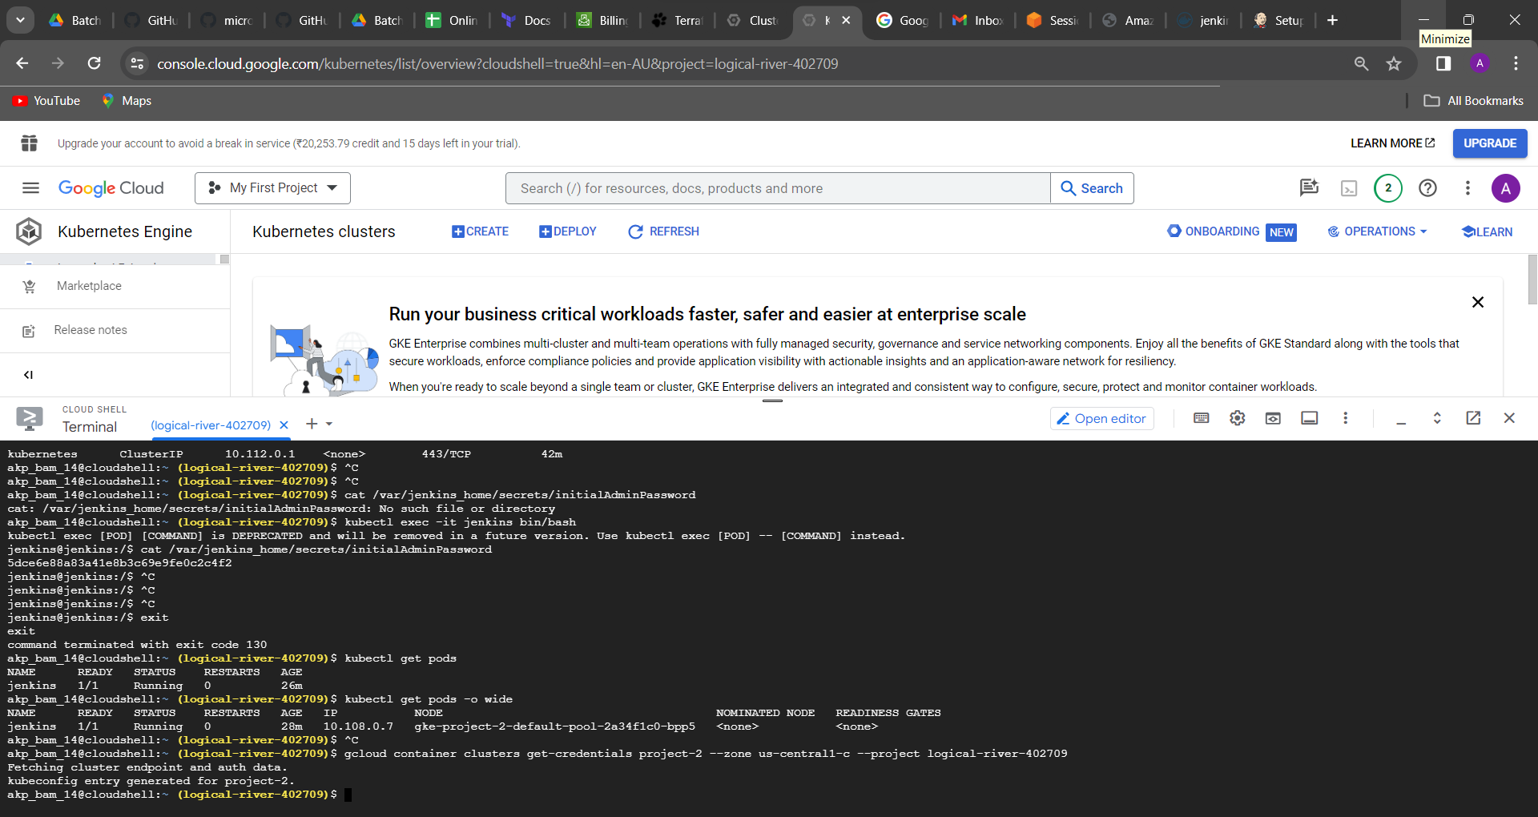

Type command: mkdir batch-33

cd batch-33

ls

git clone <https://github.com/GoogleCloudPlatform/microservices-demo.git>.

First this gcp microservice demo git repo fork to your git account

git clone <https://github.com/Anantapatra14/microservices-demo.git>

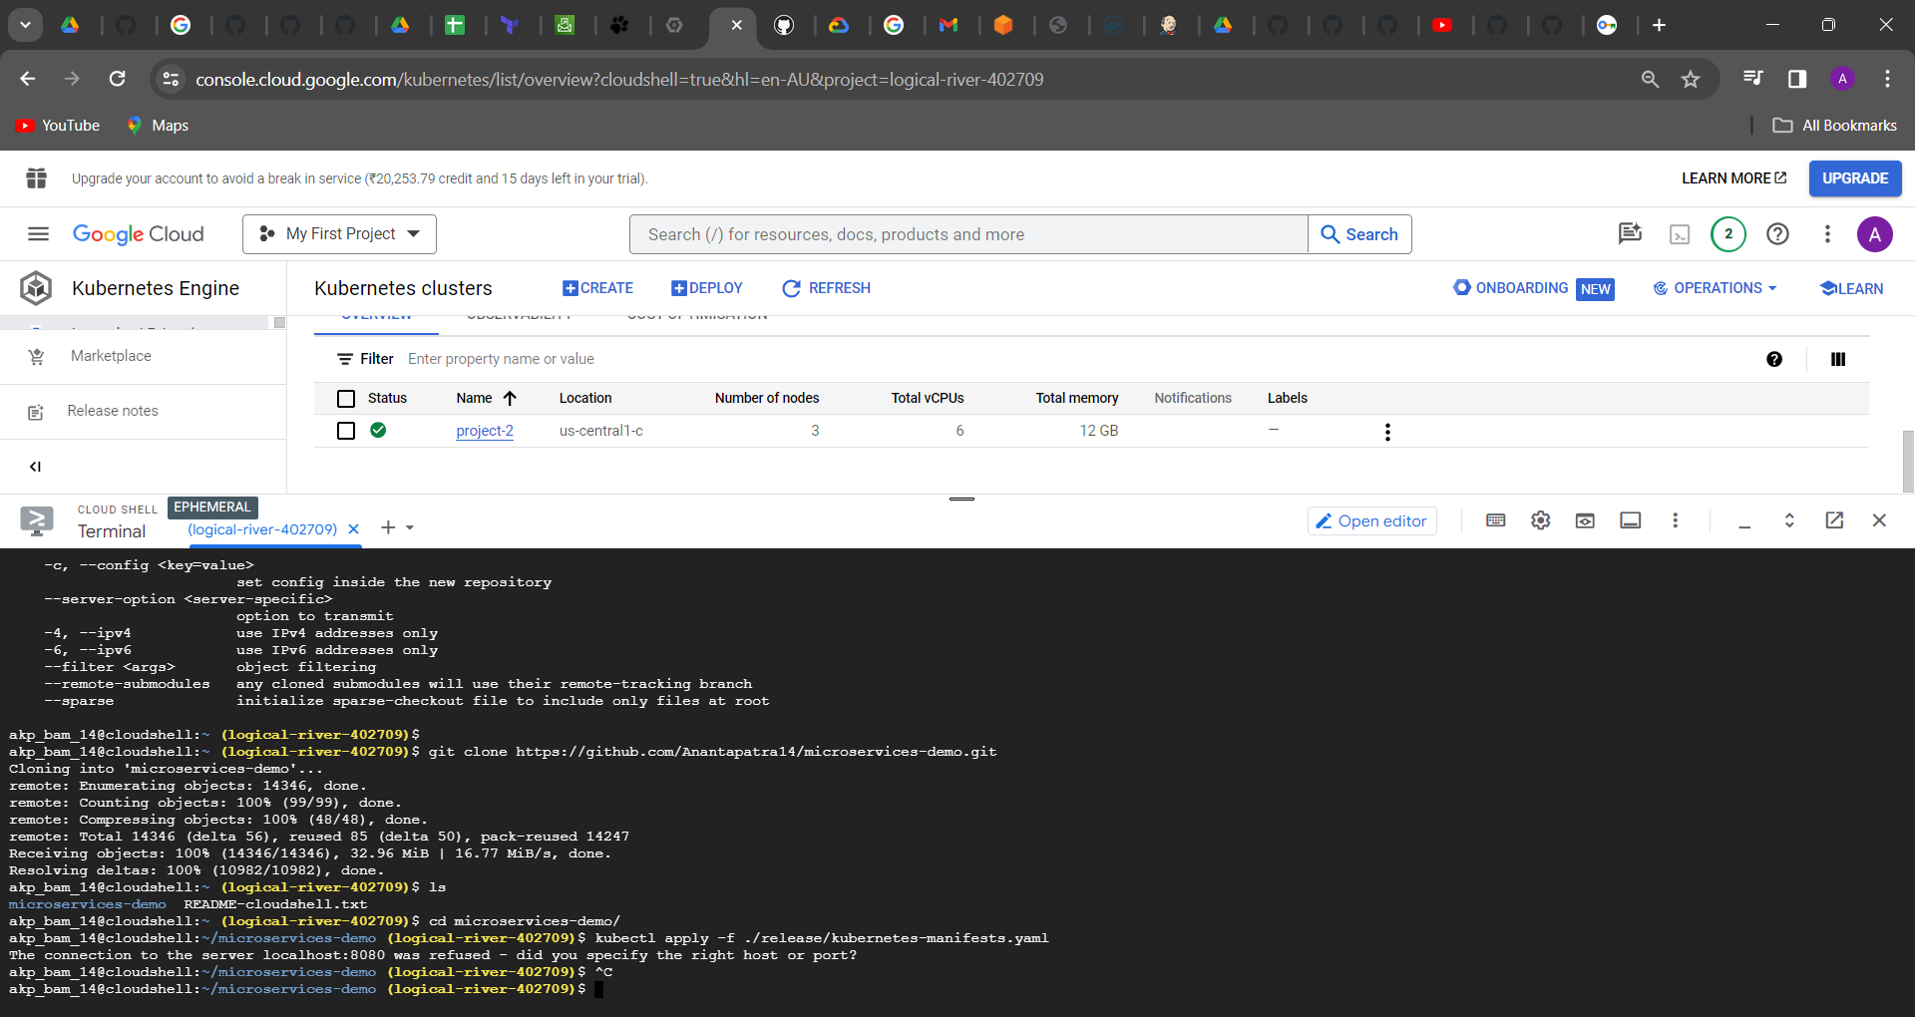

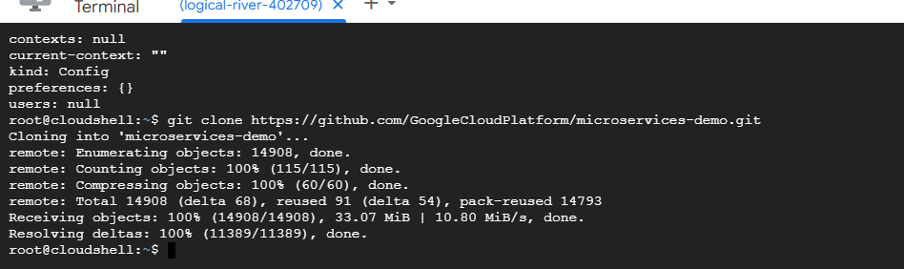

ls

cd microservices-demo/

ls

kubectl apply -f ./release/kubernetes-manifests.yaml

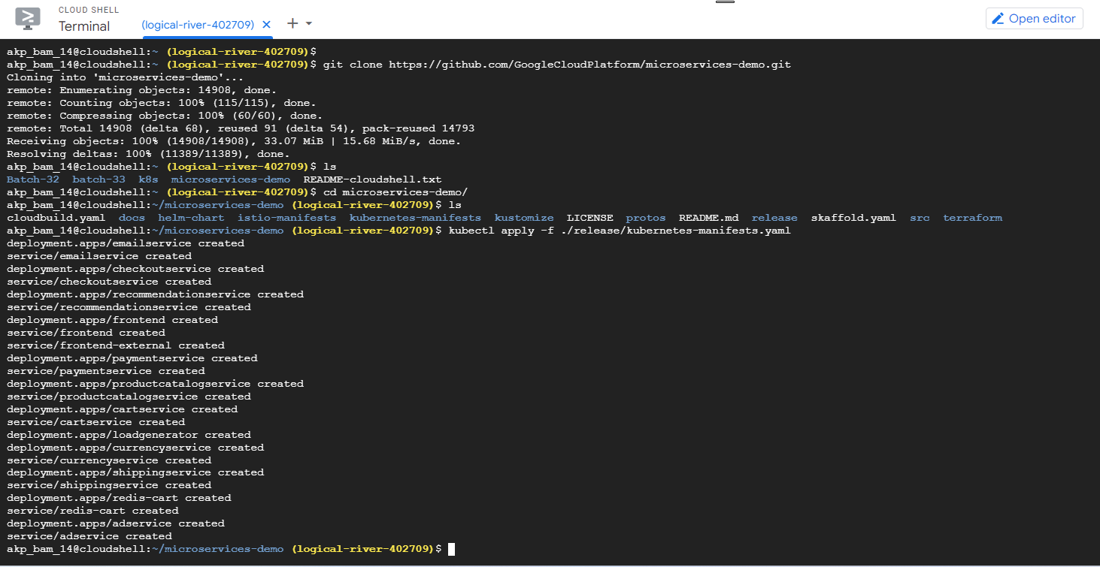

Then you have to do duplicate UI in GCP console 🡪 workloads

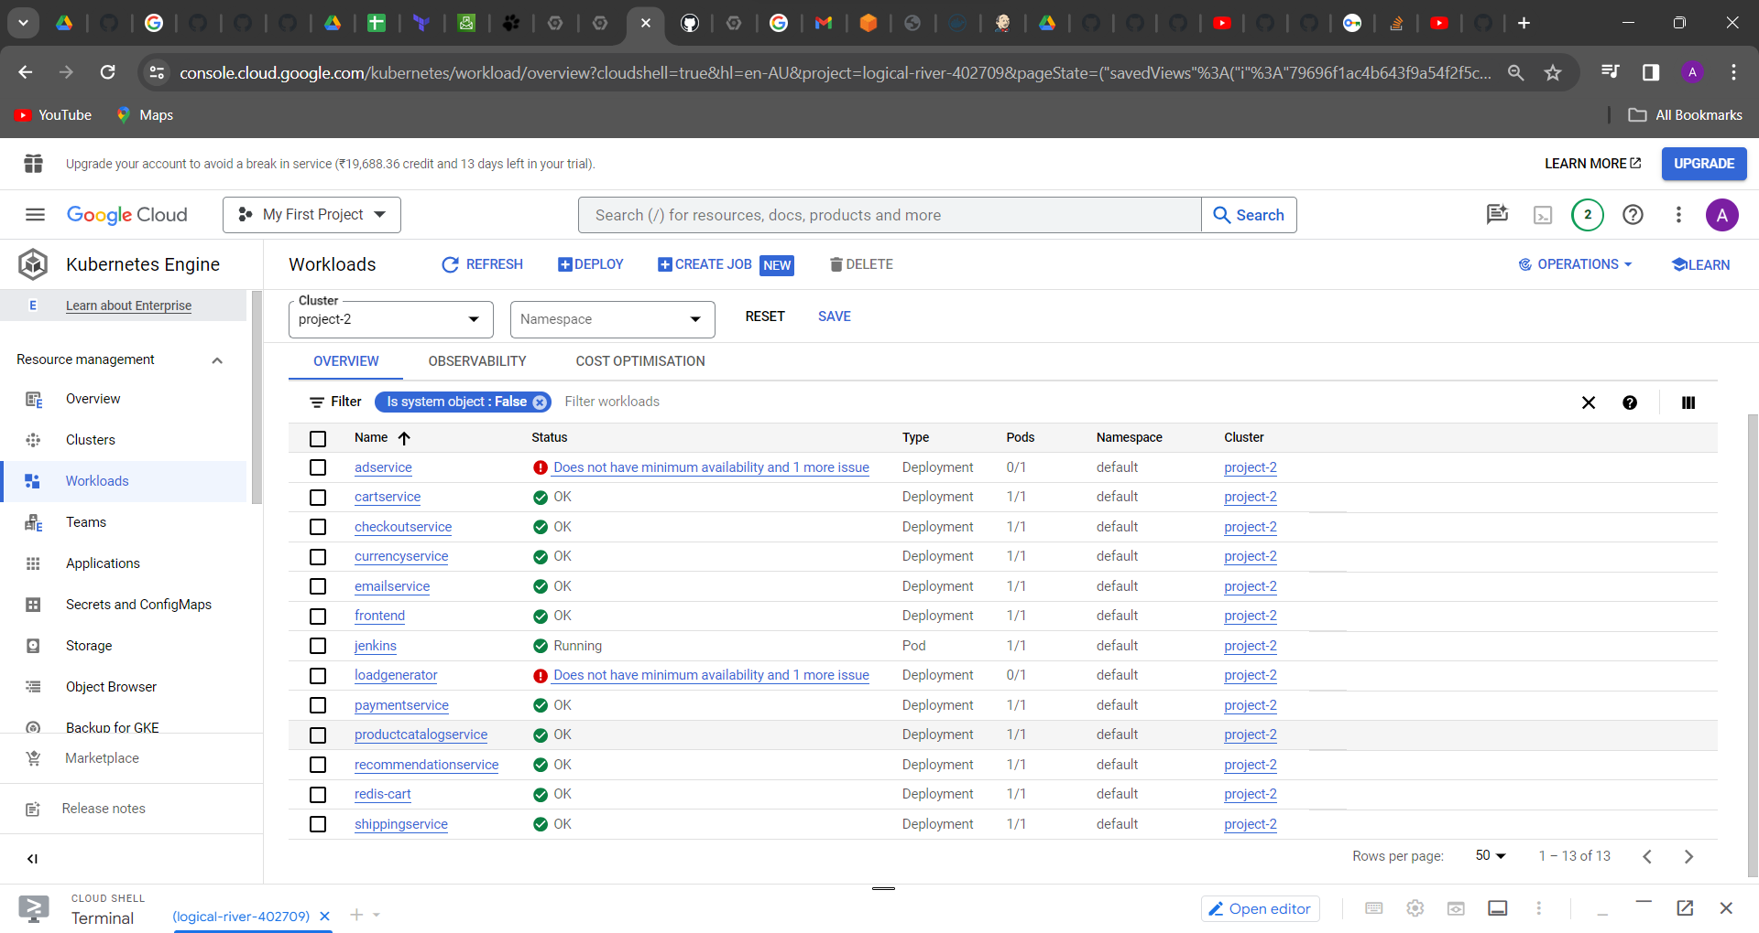

Something is running and something is failed at this point, then again refresh it

Still I am getting two failed

Command line: “kubectl get po”

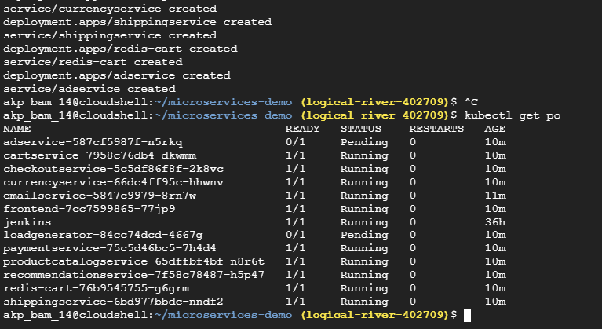

Some of the two are pending Ad service and load generator

Then go to networking in gateways, services

Here it is showing fronted external loadbalancer ip address: http://34.16.15.70/

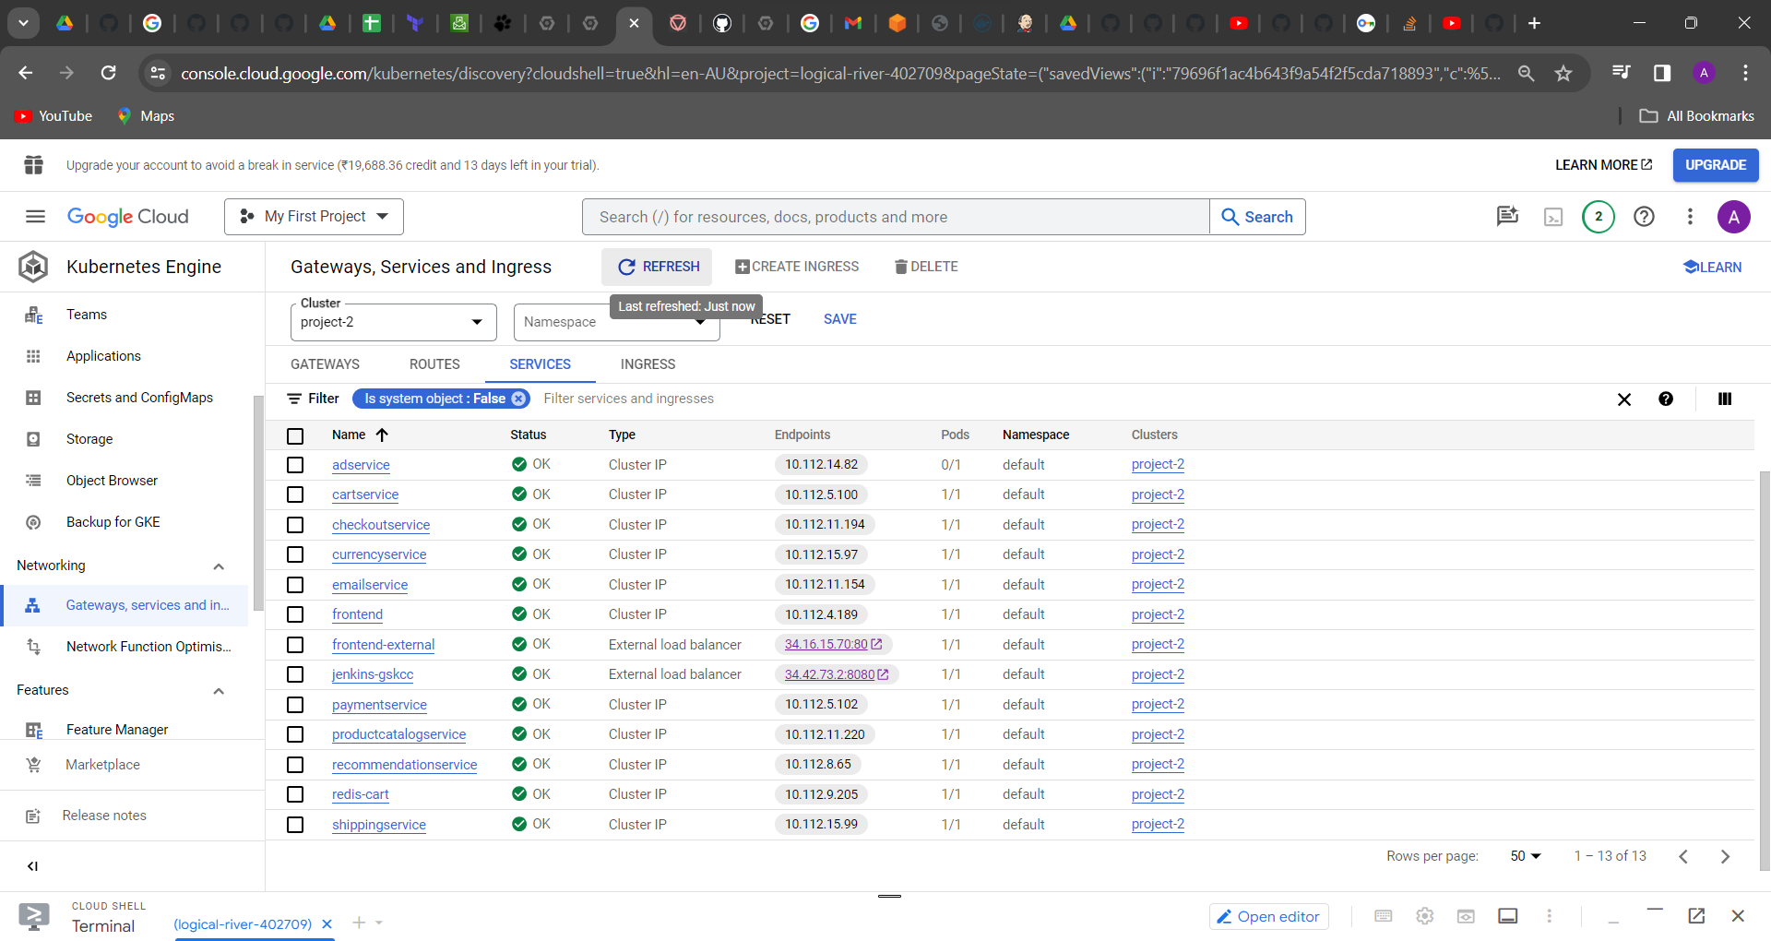

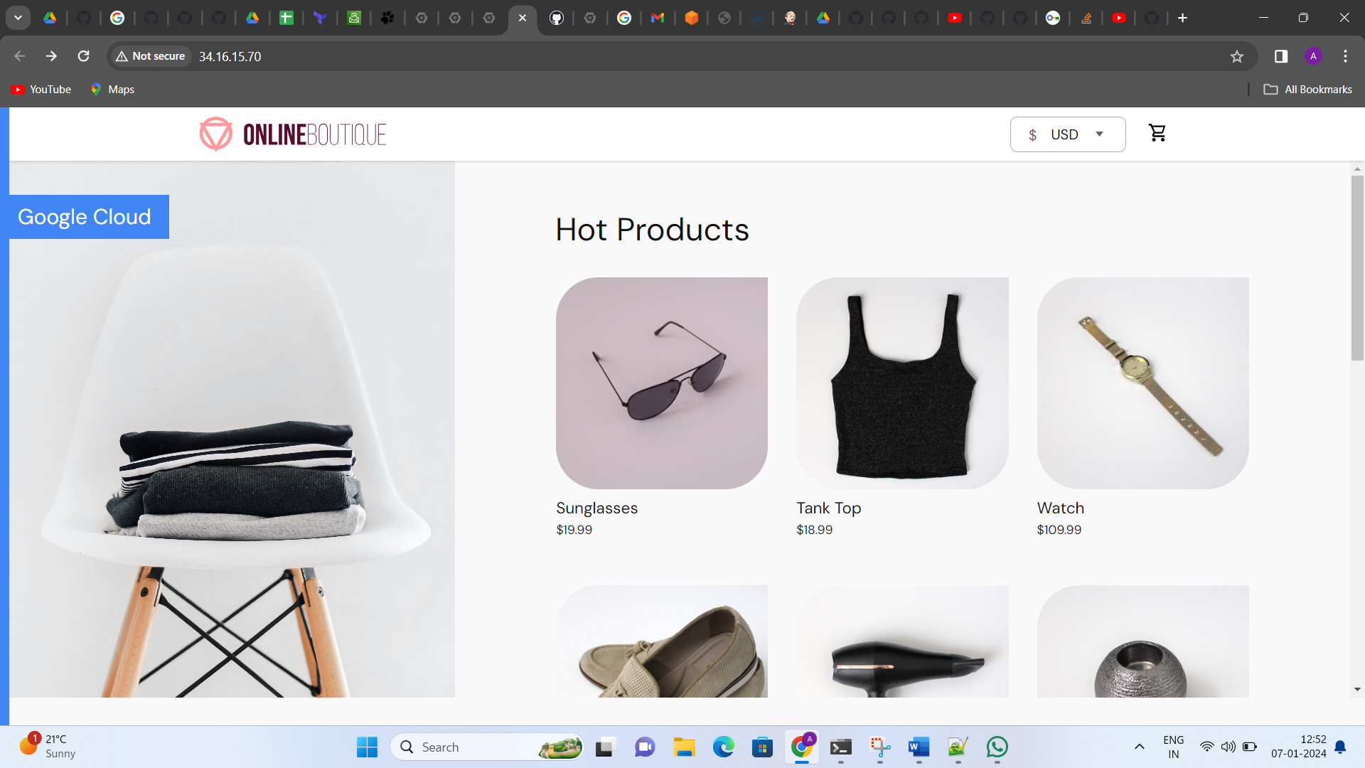

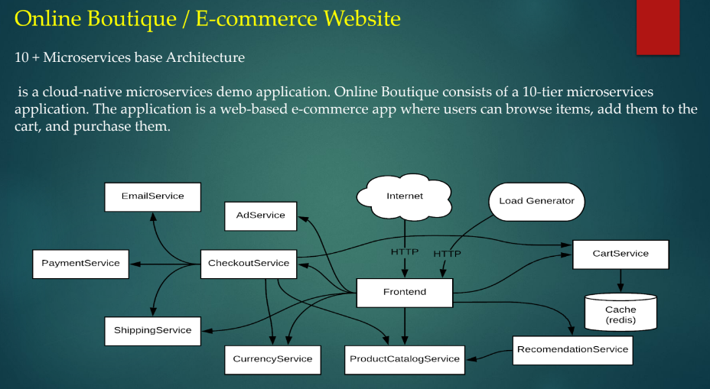

Now I am deleting the shippingservice

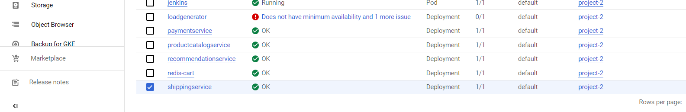

shippingservice-6bd977bbdc-nndf2 1/1 Running 0 25m

now I want to delete this shippingservice command line is

kubectl delete po shippingservice-6bd977bbdc-nndf2

kubectl get po

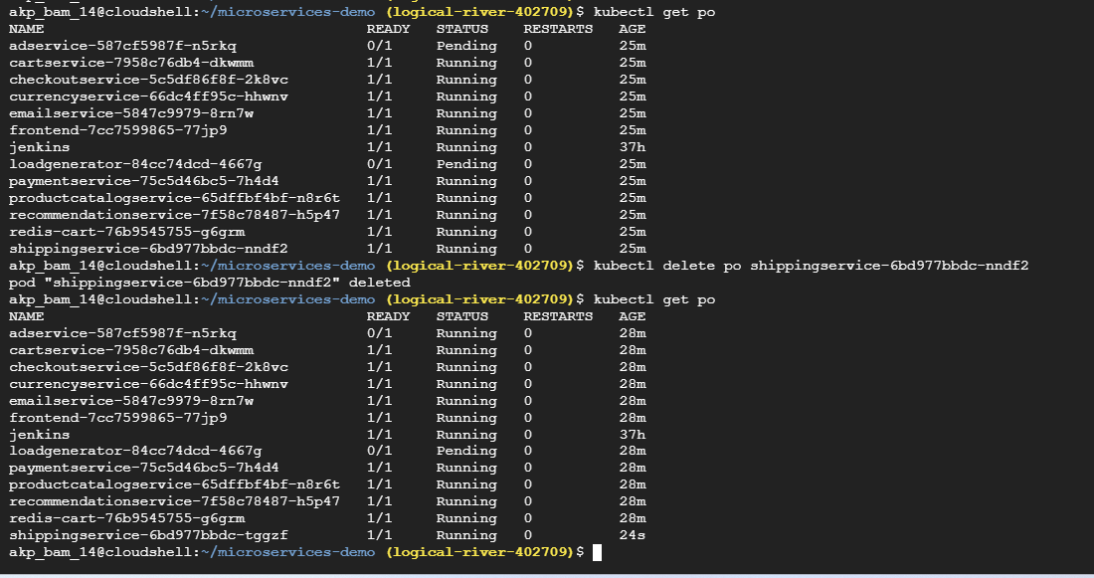

It has been deleted but again it came upon running

Now another process

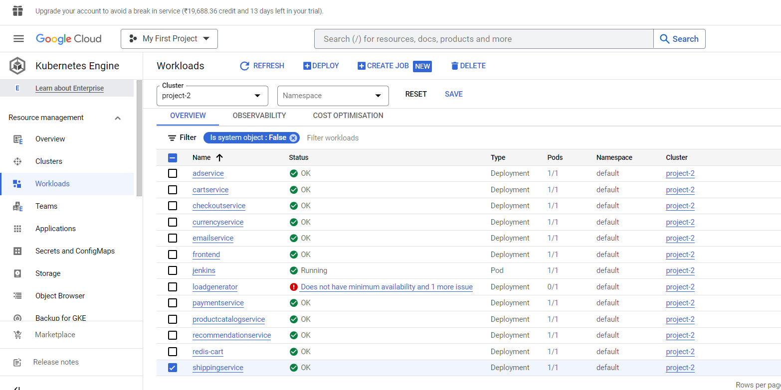

You select this shipping service and click on above option

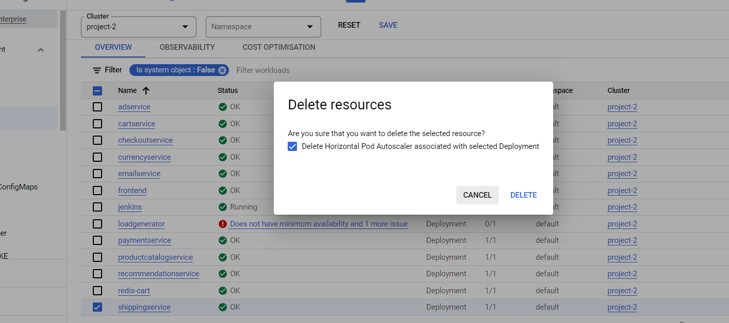

kubectl get po

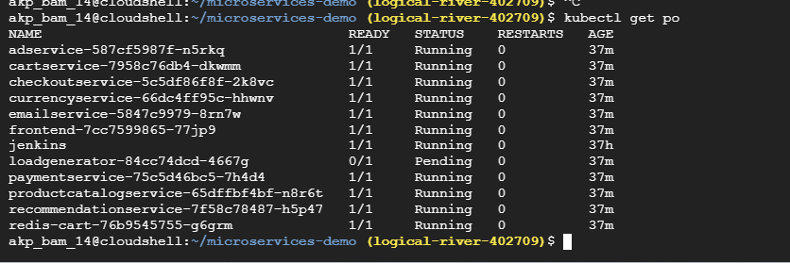

Then lets see in UI

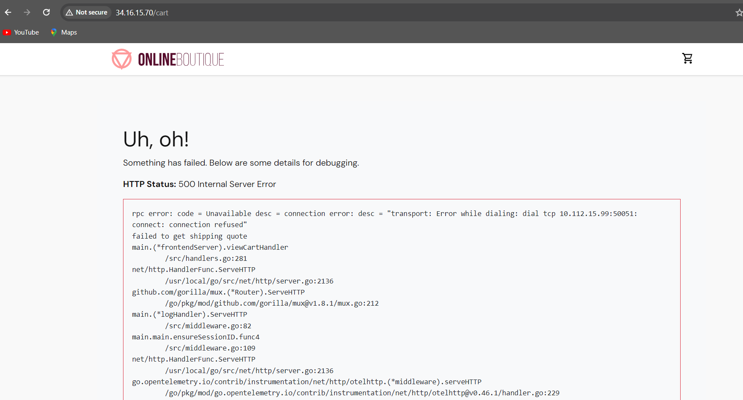

When I am going to add to cart after payment service hasn’t to come that’s why shipping service didn’t go to the page. My e-commerce website is running.

As a devops engineer how to fix it, how to redeploy

Then go to command line

kubectl apply -f ./release/kubernetes-manifests.yaml

kubectl get po

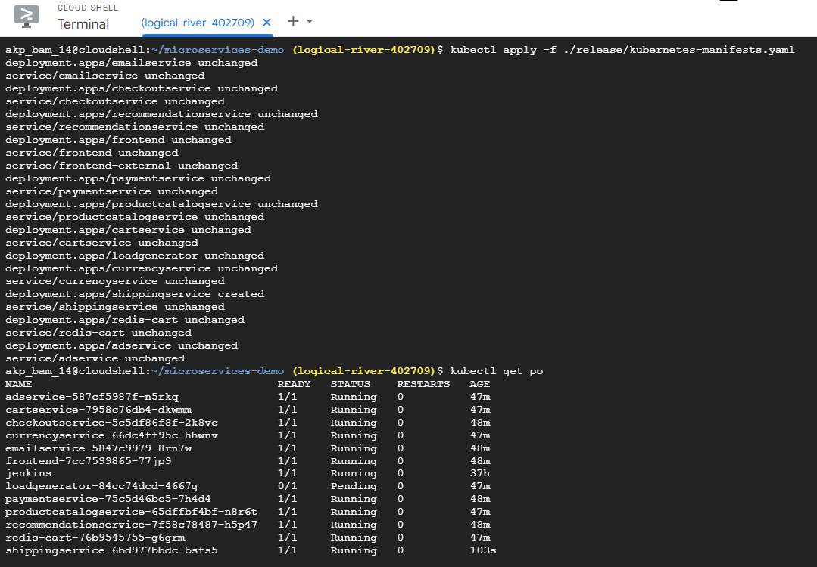

Now it is working

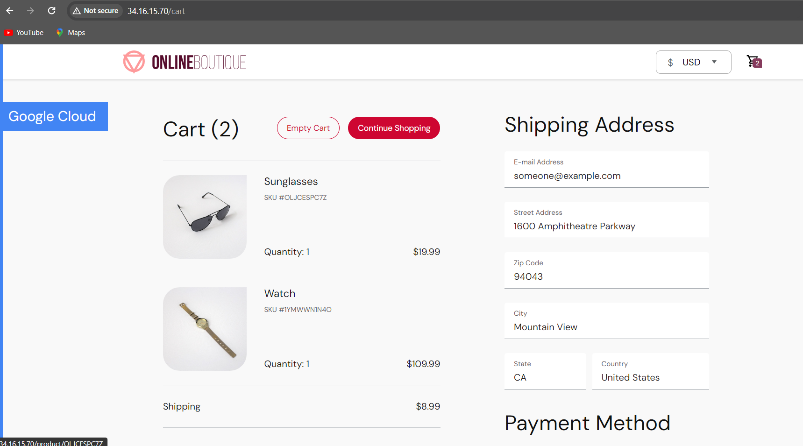

Or if you facing some trouble then

kubectl logs shippingservice-6bd977bbdc-nndf2

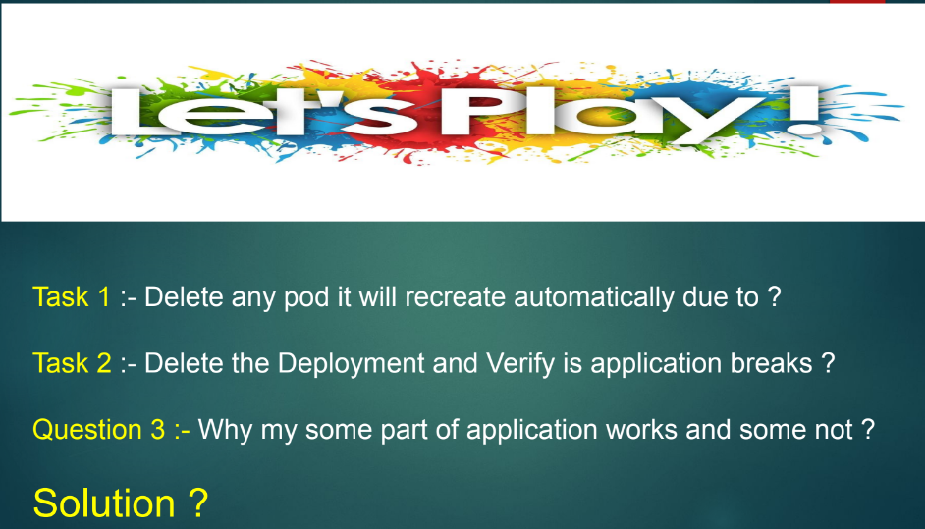

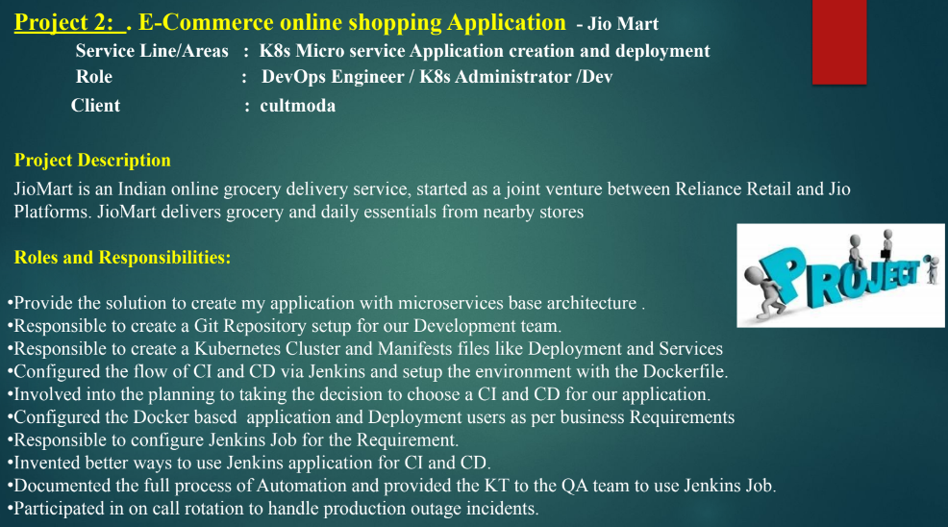

What is manifests?

* In Kubernetes whatever the code has been written in to the yaml language that is called manifests

Multiple peoples are there in this project.

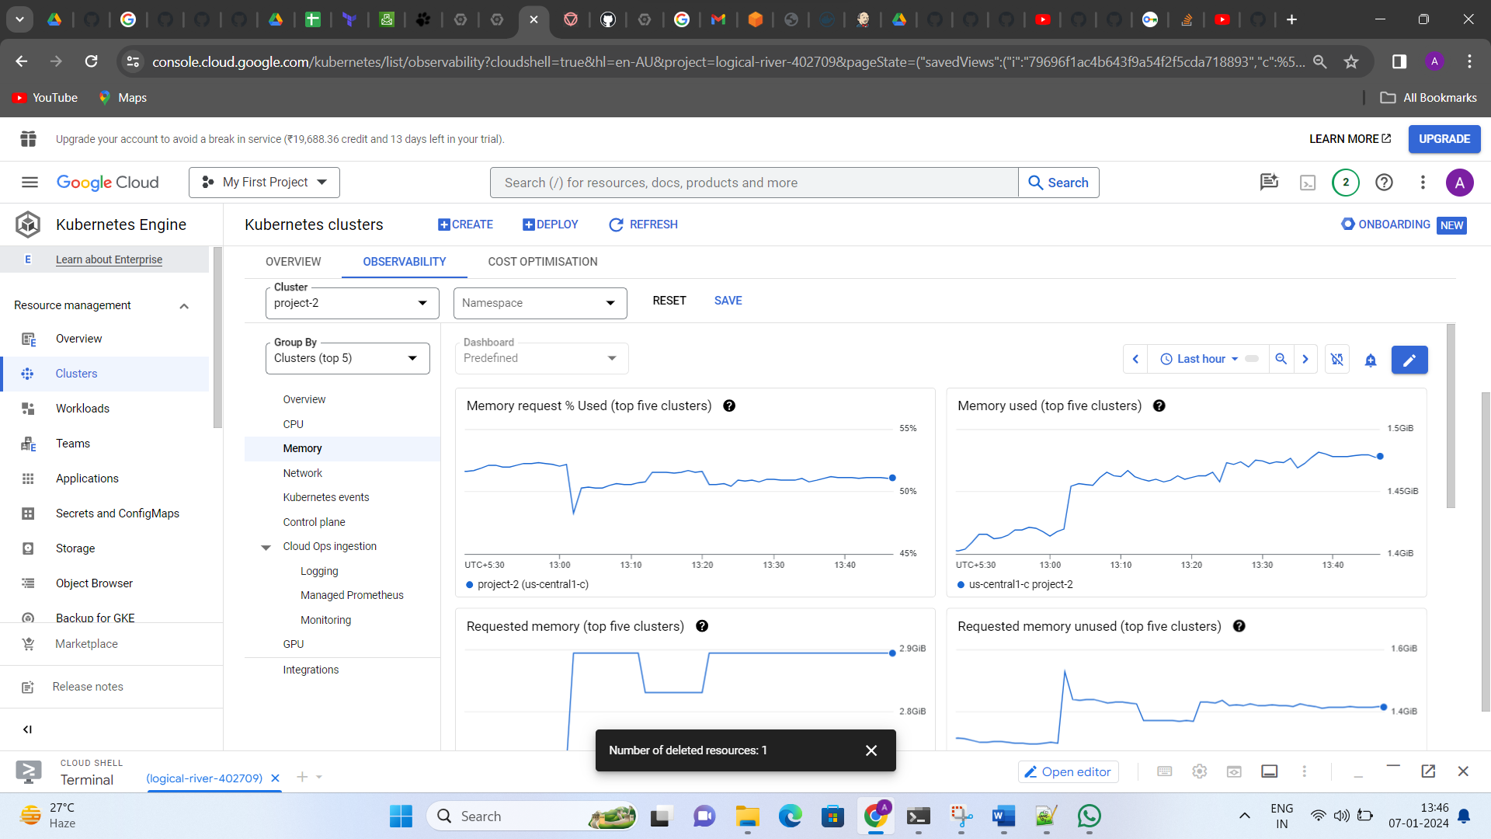

<https://logz.io/blog/amazon-eks-cluster/>

<https://www.youtube.com/watch?v=aZd0UolVwD4>

